Centre: FAT 2

590 Cach Mang Thang Tam street, District 3, HCM city

Design Document

**WEB SITE FASHION SHOP**

**Faculty** : **Dương Trọng Phú Sơn**

**Batch No** : F3-13-1312-T0

**Group No** : 1

**Students**:

|  |  |
| --- | --- |
| **Full Name** | **Roll No** |
| Nguyễn Cảnh Khánh Trình (Leader) | Student780645 |
| Lương Tấn Chức | Student777751 |
| Đoàn Đình Huy | Student785889 |
| Trần Minh Phát | Student812170 |
| Phạm Tân Yên | Student785557 |
| Trần Đức Hòa | Student597312 |

Review 1

1. Introduction 6

2. Existing Scenario 6

3. Customer Requirement Specification 6

3.1 Guest 6

3.2 Customer 6

4. Functional Requirement Specification 7

4.1 Guest can register as User 7

4.2 Guest can login as User 8

4.3 Guest, User can view product detail 8

4.4 Guest, User can search product 8

4.5 Guest, User can sent contact to manager. 8

4.6 Admin can manager user 8

4.7 Admin can manager product category 9

4.8 Admin can manager product brand 9

4.9 Admin can manager orders 10

4.10 Admin can view system statistics 10

5. System Requirements 11

5.1 Hardware 11

5.2 Software 11

6 Development Software 12

7 Techonology 12

8 Project Scope 12

9 Task Sheet 13

Review 2

1 Use Case and Sequence Diagram 15

1.1 Guest 15

1.2 User 21

1.3 Admin 32

2 Entity Relationship Diagram (ERD) 61

2.1 ERD 61

2.2 Entity 61

3 Task Sheet 66

Review 3

1 Database Relationship Diagram 68

2 Table Definition 68

2.1 Product 68

2.2 Brand 69

3 Sitemap 76

3.1 Admin Page 76

3.2 User Page 77

4 GUI Design 78

4.1 User page 78

4.1.1 Register Page 78

4.1.2 Login Page 79

4.1.3 Product Page 81

4.1.4 Product Detail Page 81

4.1.5 Display Category 82

4.1.6 Category page 83

4.1.7 Change password 84

4.1.8 Contact page 85

4.1.9 Comment page 87

4.1.10 News page 88

4.1.11 News Detail Page 89

4.2 Admin page 91

4.2.1 Login page 91

4.2.2 Change password page 91

4.2.3 Brand manager 92

4.2.4 Modify brand page 94

4.2.5 Delete Brand page 95

4.2.6 News manager 95

4.2.7 Add New 96

4.2.8 Modify new category 97

4.2.9 List News 97

4.2.10 Add News 98

4.2.11 Modify news 99

4.2.12 Contact Manager 100

4.2.13 Detail contact 102

4.2.14 Comment manager 103

4.2.15 User manager 104

4.2.16 List product 105

4.2.17 Modify product 107

4.2.18 Product detail 108

4.2.19 Category manager 110

4.2.20 Category detail 111

4.2.21 Add category 112

4.2.22 Modify category 113

5 Task Sheet 115

**REVIEW 1**

# Introduction

* Nowaday, selling online becomes more and more popular. Instead of going to a store and wasting a lot of time, now you can just stay at home and visit an online store. Whatever you can do with an original store, you can do with an online store, you can choose your products, buy them and make a payment. Because of that convenience, our group will make a website about online fashion store.

# Existing Scenario

* For customer :
* Customer is being given a list of newest products in the market to choose.
* Each product has all details customer needs to know to have a suitable choice.
* Helping customer easily classify and search the products they are looking for.
* Helping customer orders online, save on money, time.
* For admin :
* Easily adding new brands also updating information on old products.
* Convenient to manage customer.
* Convenient to manage product.
* Convenient to manage customer.
* Convenient to manage turnover, profits.

# Customer Requirement Specification

* There will be 3 types of users
* Guest
* Customer
* Admin

## Guest

* Register with the system
* Guest user will be able to browse through the system, view the products, search etc.
* But he will not be able to do shopping.

## Customer

* Login with user name and password, can retrieve the password if forgot.
* Search the products
* See the picture and features of the selected product
* Compare the products of various brands
* Add the selected products in cart
* Calculate and pay the bill
* View the history of their orders.
* Rate the products and write their comments
* Can avail the offers like special discounts/Buy 1 get 1 free/ few copies left etc…
  1. Admin
* Manage user account
* Add / update / delete categories of products
* Add / update / delete products
* Add / update / delete brands
* Manage bill of customer
* Should be able to generate various reports

# Functional Requirement Specification

## Guest can register as User

* + 1. Description
* The system must provide a page to allow guest create their accounts with the following information:
* Username
* Password
* Fullname
* Email
* Phone
* Address
  + 1. Functional Requirements

REQ01 : User must provide Username, Password, Fullname, Email, Phone, Address to create an account.

REQ02 : Email and Username is unique

## Guest can login as User

* + 1. Description
* The system must provide a page to allow guest login as User
  + 1. Function Requirements

REQ03 : User must provide Username or Email and Password to log in into website

## Guest, User can view product detail

* + 1. Description
* User can show product detail by click a link show in index or category page
* The detail page must provide information of product. (name, thumb image, description, price, comment and relation product)
* The user can show the Buy Now button for add product to cart
  + 1. Function Requirements

REQ04 : User must click a link in index

## Guest, User can search product

* + 1. Description
* Guest, User can search the Product base on Category, Cost, Brand
  + 1. Function Requirements

REQ05 : 1Guest, User must provide the name or the number and select action

## Guest, User can sent contact to manager.

* + 1. Description
* Guest and user can send contact information directly to admin by clicking on “Liên hệ”
* Information the user sending will appear on managing page of admin.
  + 1. Function Requirements

REQ06 : Guest and user must provide name, address, contact.

REQ07 : After completing, click “Liên hệ” to send the information.

## Admin can manager user

* + 1. Description
* Admin can manage customer after logging in managing page. At the managing page, admin can view customers list, change customer information, block or delete customer account.
  + 1. Function Requirements

REQ08 : The system must provide the managing page, there will provide customers list with managing functions.

REQ09 : In blocking case, account of customer will still be existing on system but customer can’t login and buy products...

REQ10 : In deleting case, account of customer will be deleted completely from system include personal information, trading history.

REQ11 : In changing information case, admin must put in all personal information of user and can’t change login name or email of customer.

REQ12 : Admin can’t change password of user.

## Admin can manager product category

* + 1. Description
* Admin can manage products category with functions: adding, deleting and changing products category.
* Only after logging in the managing page, admin is able to use those functions.
  + 1. Function Requirements

REQ13 : The system must provide the products category with functions: adding, deleting and changing products category.

REQ14 : In deleting case, there will be a dialog box appearing for admin to confirm. In confirming deleting case, the deleted category will be gone with all the products belong to it.

REQ15 : In adding or changing case, admin must put in all fields.

## Admin can manager product brand

* + 1. Description
* Admin can manage products brand with functions: adding, deleting and changing products brand.
* Only after logging in the managing page, admin is able to use those functions.
  + 1. Function Requirements

REQ16 : The system must provide the products brand with functions: adding, deleting and changing products brand.

REQ17 : In deleting case, there will be a dialog box appearing for admin to confirm. In confirming deleting case, the deleted brand will be gone with all the products belong to it.

REQ18 : In adding or changing case, admin must put in all fields.

## Admin can manager orders

* + 1. Description
* Admin can view, delete or change the status of orders.
* Only after logging in the managing page, admin is able to use those functions.
  + 1. Function Requirements

REQ19 : The system must provide the product orders list in newest arrangement and provide functions to manage orders.

REQ20 : In deleting case, there will be a dialog box appearing for admin to confirm. In confirming deleting case, the deleted order will be gone.

REQ21 : In changing status case, there will be those statuses

## Admin can view system statistics

* + 1. Description
* Admin can view system statistics with details on the quantity of custermer buying in month, year; the quantity of new customer registration; the profits in month, year...
* Only after logging in the managing page, admin is able to use those functions.
  + 1. Function Requirements

REQ22 : The system must provide system statistics page with those details:

* The quantity of new customer registration in month, year.
* The quantity of order in month, year.
* The trading money and profits in month, year.
* The quantity of current products.

# System Requirements

## Hardware

* + 1. Web Server

|  |  |
| --- | --- |
| Processor | Core i3 or higher. |
| Memory | 3GB RAM or greater. |
| Modem/ADSL | Connecting to internet 24/24 |

* + 1. Client

|  |  |
| --- | --- |
| Processor | Core i3 or higher. |
| Memory | 3GB RAM or greater. |
| Monitor | Super VGA (1208x600) |
| Pointing Device | Microsoft Mouse, Microsoft IntelliMouse®, or compatible pointing device. |
| Modem/ADSL | Connecting to internet |

## Software

* + 1. Web Server

|  |  |
| --- | --- |
| Operation System | Windows 8/8.1 |
| Browser | Chrome 40, Fire fox 40 or higher. |
| Database | Microsoft SQL Server 2012 |
| Software | Java SDK 1.7 |
| Server | GlassFish 4 |
| Framework | JSF 2.0 |

* + 1. Client

|  |  |
| --- | --- |
| Operation System | Windows 7 or later. |
| Browser | Chrome 40, Fire fox 40 or higher. |

# Development Software

* Microsoft Windows 8
* Netbean 7.4
* Java SDK 1.7
* GlassFish 4
* Microsoft SQL Server 2012
* Chrome 40 or higher

# Techonology

* J2EE
* JSF Framework
* HTML 5
* CSS 3

# Project Scope

* Not accept payment online
* Cannot management warehouse

# Task Sheet

|  |  |  |  |  |  |
| --- | --- | --- | --- | --- | --- |
| Members | | Task | Date | | Status |
| No | Full Name |  | Start Date | Date Finish |  |
| 1. | Nguyễn Cảnh Khánh Trình | Joint working | 3/8/2015 | 6/8/2015 | Completed |
| 2. | Lương Tấn Chức | Joint working | Completed |
| 3. | Phạm Tân Yên | Joint working | Completed |
| 4. | Trần Minh Phát | Joint working | Completed |
| 5 | Trần Đức Hoà | Joint working | Completed |
| 6 | Đoàn Đình Huy | Joint working | Completed |

|  |  |
| --- | --- |
| Leader | Faculty |
|  |  |
| Nguyễn Cảnh Khánh Trình | Dương Trọng Phú Sơn |

**REVIEW 2**

# Use Case and Sequence Diagram

## Guest

* + 1. Register as User

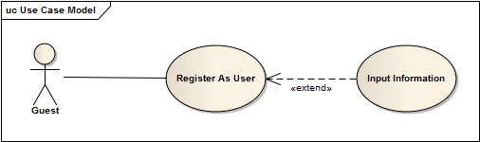

|  |  |  |
| --- | --- | --- |
| **Author** | Lương Tấn Chức | |
| **Use Case Name** | Register As User | |
| **Actors** | Guest | |
| **Description** | Guest wants to register with the website to become a User member. | |
| **Requirements** | Guest provides Guest’s information | |
| **Pre-conditions** |  | |
| **Post-conditions** | Success: Guest creates a User account in this website  Fail: Refill information | |
| **Basic flow** | Actor Actions:  1. Actor clicks ‘Register’ link in Home page  3. Actor clicks on to Agree button.  5. Actor inputs register’s information, select ‘User’ radio button and click ‘Register’ button. [Alternative 1] | System Responses:  2. System redirects to Registration Policy page.  4. System redirects to Register page and displays Registration form with the following control :  - ‘UserName’ text field  - ‘Password’ text field  - ‘Confirm Password’ text field  - ‘Name’ text field  - ‘Address’ text field  - ‘Phone’ text field  - ‘Email’ text field  -- ‘Register’ button  - ‘Back to Home’ button  6. System checks the information  [Exception 1]  7. System inserts the account into database, show message: ‘Your account has been created!’ and then redirects to Login page. |
| **Alternative flow** | Actor Actions:  [Alternative 1]  1. Actor click ‘Back to Home’ button. | System Responses:  2. System returns to Home page. |
| **Exception flow** | Actor Actions:  [Exception 1]  1. Actor lefts ‘UserName’ text field blank.  2. UserName has already exists.  3. Actor lefts ‘Password’ text field blank.  4. Actor lefts ‘Confirm Password’ text field blank.  5. Password and confirm password don’t match.  6. Actor lefts ‘Name’ text field blank.  7. Actor lefts ‘Address’ text field blank.  8. Actor lefts ‘Phone’ text field blank.  9. Input phone not in numeric or phone length not in range 8 – 14 character.  10. Actor lefts ‘Email’ text field blank or input an invalid email address.  11. Actor left ‘Captcha’ text field blank or input an unmatch value. | System Responses:  System displays message to Actor :  - ‘UserName cannot be blank’.  - ‘This Username has already exist!’.  - ‘Password cannot be blank’’.  - ‘Confirm Password can’t be blank’.  - ‘Confirm password not match password.’  - ‘Name cannot be blank’.  - ‘Address cannot be blank’.  - ‘Phone is invalid’.  - ‘The phone number should be numeric only and must be between 8 and 14 digits’.  - ‘Email is invalid’. |

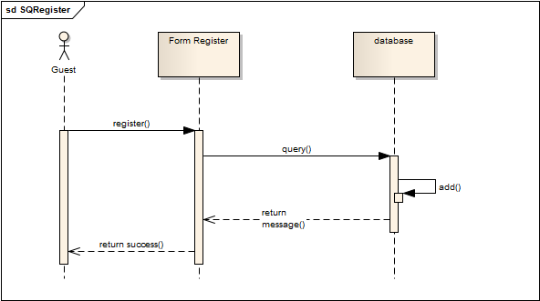

* + 1. Contact to Manager

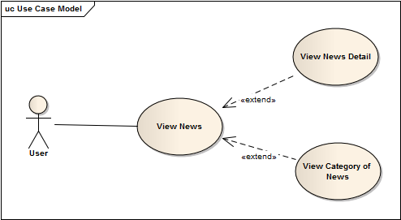

|  |  |  |
| --- | --- | --- |
| **Author** | Phạm Tân Yên | |
| **Use Case Name** | Tintuc | |
| **Actors** | Guest | |
| **Description** | View news | |
| **Requirements** |  | |
| **Pre-conditions** |  | |
| **Post-conditions** |  | |
| **Basic flow** | Actor actions:  1. From any page, actor clicks on to the ‘Tin Tức’ on MainMenu.  3. Actor:   * Where actor click ‘News Title’ or ‘ReadMore’ | System response:  2. System redirects to ‘TinTuc’ page and display ‘List of News’.  4. System redirects to ‘DetailTinTuc’ page and display ‘Detail of News’. |
| Or Actor actions:  1. From any page, actor clicks on to the ‘SubMenu’ on MainMenu-Tintuc.  3. Actor:   * Where actor click ‘News Title’ or ‘ReadMore’ | System response:  2. System redirects to ‘DanhMucTinTuc’ page and display ‘List of News of News Catelory’ actor want.  4. System redirects to ‘DetailTinTuc’ page and display ‘Detail of News’. |
| **Alternative flow** |  |  |
| **Exception flow** |  |  |

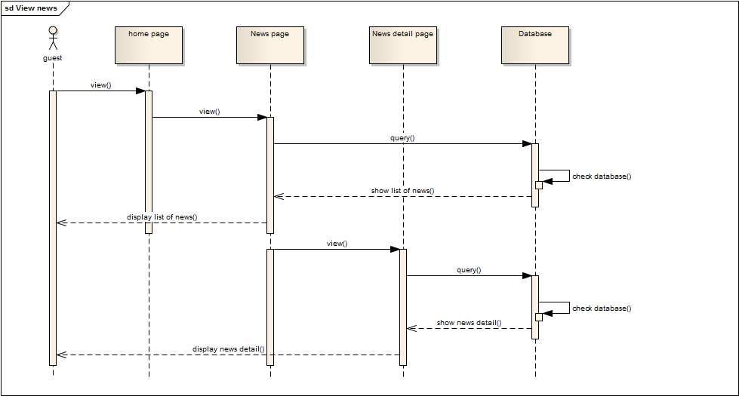

## User

* + 1. Login to website

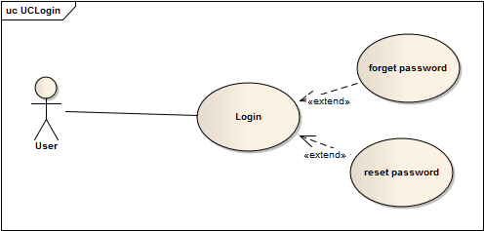

|  |  |  |
| --- | --- | --- |
| **Author** | Lương Tấn Chức | |
| **Use Case Name** | Login To website | |
| **Actors** | User | |
| **Description** | User wants to login to website as User member. | |
| **Requirements** | Actor provides username and password | |
| **Pre-conditions** |  | |
| **Post-conditions** | Success: User logged in to website.  Fail: Refill information | |
| **Basic flow** | Actor Actions:  1. Actor go to Home page of website.  3. Actor inputs UserName and Password, then click the Login button. | System Responses:  2. System redirects to Home page and displays Login form on the left with the following control:  - ‘UserName’ text field  - ‘Password’ text field  - ‘Go’ button  4. System checks the information  [Exception 1]  5. System redirects to Actor’s Home page. |
| **Alternative flow** | Actor Actions:  [Alternative 2]  1. Actor click ‘OK’ button, inputs UserName and Password, then click the Login button.  [Alternative 1]  1. Actor click ‘Back to Home’ button. | System Responses:  2. System checks the information  [Exception 1]  3. System redirects to Actor’s Home page.  2. System returns to Home page. |
| **Exception flow** | Actor Actions:  [Exception 1]  1. Actor input invalid username and password. | System Responses:  - System redirect to Login page with the following controls:  - ‘UserName’ text field  - ‘Password’ text field  - ‘Login’ button. |

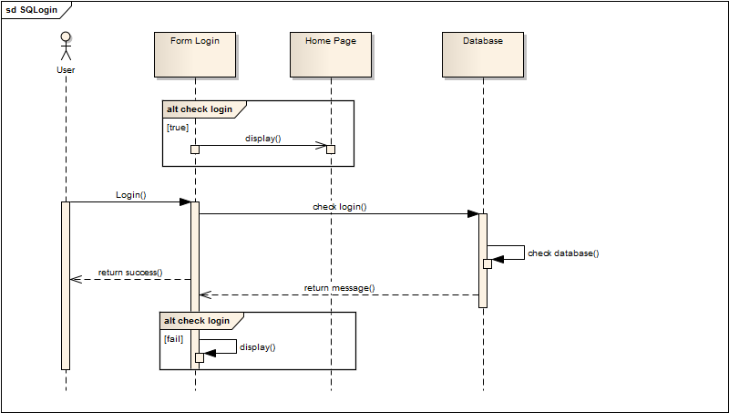

* + 1. Edit profile

|  |  |  |
| --- | --- | --- |
| **Author** | Nguyễn Cảnh Khánh Trình | |
| **Use Case Name** | Change Profile | |
| **Actors** | User | |
| **Description** | Change Profile | |
| **Requirements** |  | |
| **Pre-conditions** | Already login into the System as user | |
| **Post-conditions** | Success: Update user’s details into the database. | |
| **Basic flow** | Actor actions:  1. From ‘home or any’ page, actor clicks on to the ‘Change profile’ button  3. Actor:   * Inputs name into ‘CustomerName’ textfield. * Inputs address into ‘CustomerAddress’ textfield. * Inputs email into ‘CustomerEmail’ textfield. * Inputs phone into ‘Customerphone’ textfield.   Clicks on to ‘Add’ button to finish adding. [Alternative 1] | System response:  2. System redirects to ‘Change password’ page and display form with the following controls:  ‘Username’ label  ‘CustomerName’ Textfield  ‘CustomerAddress’ Textfield  ‘CustomerEmail’ Textfield  ‘CustomerPhone’ Textfield |
| **Alternative flow** | [Alternative 1]  1. Actor clicks on to ‘Cancel’ button | 1. System redirects to ‘View List of Customers’ page |
| **Exception flow** | [Exception 1]  1. Actor lefts ‘CustomerName’ textfield.  2. Actor lefts ‘CustomerAddress’ textfield.  3. Actor lefts ‘CustomerEmail’ textfield  4. 2. Actor lefts ‘CustomerPhone’ textfield | System displays a message to notice actor:  “CustomerName cannot be blank. Please input News name.”  “CustomerAddress cannot be blank. Please input address.”  “CustomerEmail cannot be blank. Please input email.”  “CustomerPhone cannot be blank. Please input phone and 10 or 11 digital.” |

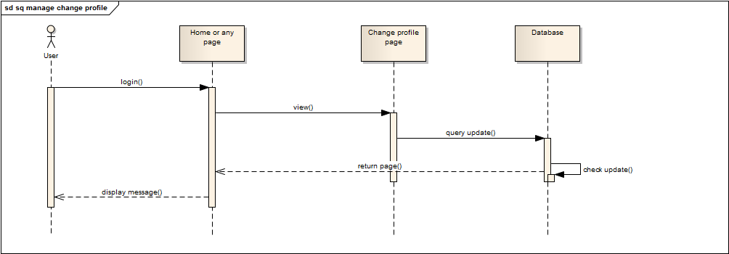

* + 1. Change password

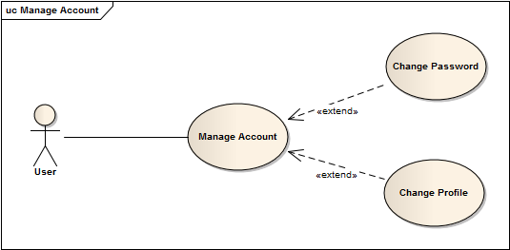

|  |  |  |
| --- | --- | --- |
| **Author** | Nguyễn Cảnh Khánh Trình | |
| **Use Case Name** | Change Password | |
| **Actors** | User | |
| **Description** | Change Password | |
| **Requirements** |  | |
| **Pre-conditions** | Already login into the System as user | |
| **Post-conditions** | Success: Update user’s password into the database. | |
| **Basic flow** | Actor actions:  1. From ‘home or any’ page, actor clicks on to the ‘Change word’ button  3. Actor:   * Inputs password into ‘old-password’ textfield. * Inputs new password into ‘New-password’ textfield. * Inputs pre-password into ‘pre-new-passowrd’ textfield.   Clicks on to ‘Add’ button to finish adding. [Alternative 1] | System response:  2. System redirects to ‘Change password’ page and display form with the following controls:  ‘user name’ Textfield  ‘old-password’ Textfield  ‘New-password’ Textfield  ‘pre-new-passowrd’ Textfield |
| **Alternative flow** | [Alternative 1]  1. Actor clicks on to ‘Cancel’ button | 1. System redirects to ‘View List of Customers’ page |
| **Exception flow** | [Exception 1]  1. Actor lefts ‘New-password’ textfield.  2. Actor lefts ‘pre-new-passowrd’ textfield. | System displays a message to notice actor:  “New-password cannot be blank. Please input News new password.”  “pre-new-passowrd cannot be blank. Please input pre-password.”  “New-password and pre-new-password is equal.” |

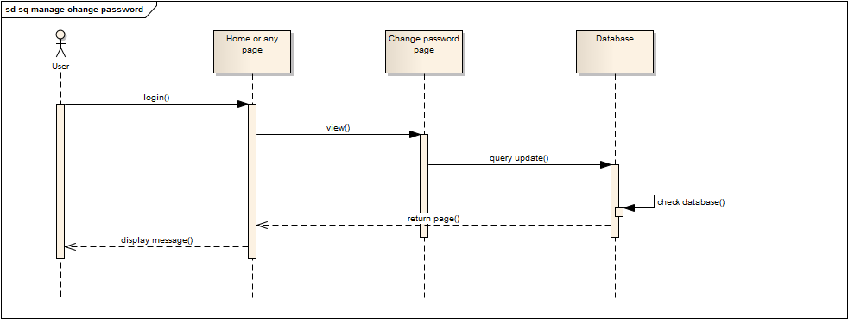

* + 1. Add comment

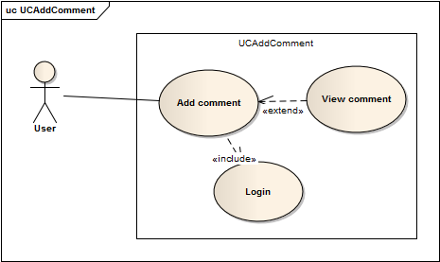

|  |  |  |
| --- | --- | --- |
| **Author** | Đoàn Đình Huy | |
| **Use Case Name** | Add comment | |
| **Actors** | User | |
| **Description** | User want to comment on a product on Home Page. | |
| **Requirements** | Actor must view detail of product | |
| **Pre-conditions** | Actor has logged in as User | |
| **Post-conditions** | Success: comment will show on comment field  Fail: Refill information | |
| **Basic flow** | Actor Actions:  -Actor clicks ‘Write comment’ tab on View product detail page  -Actor input comment and click button ‘Send’ | System Responses:  -System redirects to this page and displays form for Actor to input comment  -System will send Actor’s comment to Admin’s page so Admin can view Actor’s comment. |
| **Alternative flow** |  |  |
| **Exception flow** |  |  |

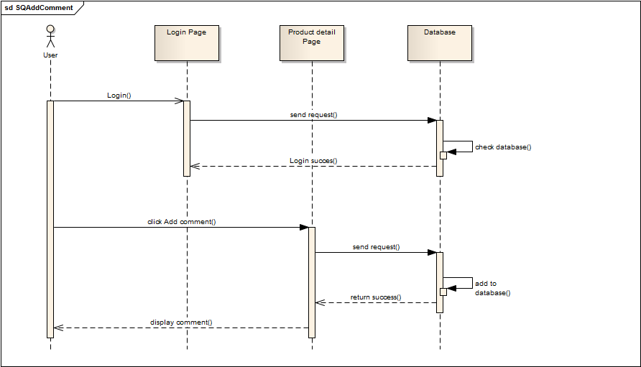

## Admin

* + 1. Manager user

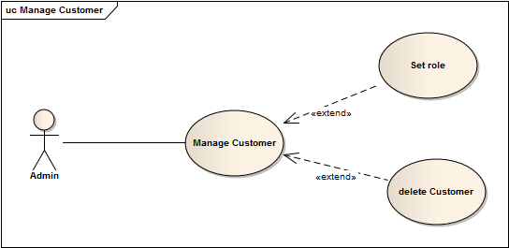

|  |  |  |
| --- | --- | --- |
| Author | Nguyễn Cảnh Khánh Trình | |
| Use Case Name | Manager Customer | |
| Actors | Administrators | |
| Description | View list of Customers | |
| Requirements |  | |
| Pre-conditions | Already login into the System as Administrator | |
| Post-conditions | Success: View list of Customers | |
| Basic flow | Actor actions:   1. From ‘Admin’ page, actor clicks on to the ‘Manager of Customer’ button. 2. Clicks on to ‘Save’ button to finish adding. [Alternative 1] | System response:  2. System redirects to ‘List of News’ page and display list of all of News in table form with control :  ‘CustomerID’ label  ‘Username’ label  ‘CustomerName’ label  ‘CustomerAddress’ label  ‘CustomerEmail’ label  ‘CustomerRole’ label  ‘CustomerPhone’ label  ‘Role’ Combobox  ‘Delete’ button  ‘Save’ button |
| Alternative flow | [Alternative 1]  1. Actor clicks on to ‘Cancel’ button | 1. System redirects to ‘View List of Customers’ page |
| Exception flow |  |  |

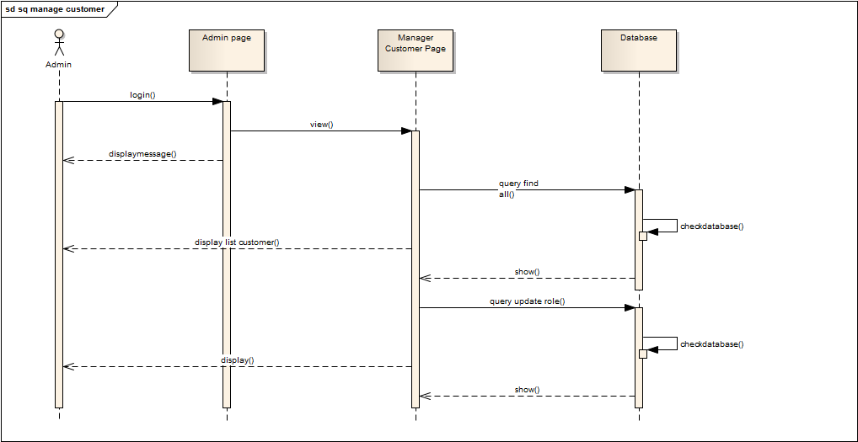

* + 1. Manager product

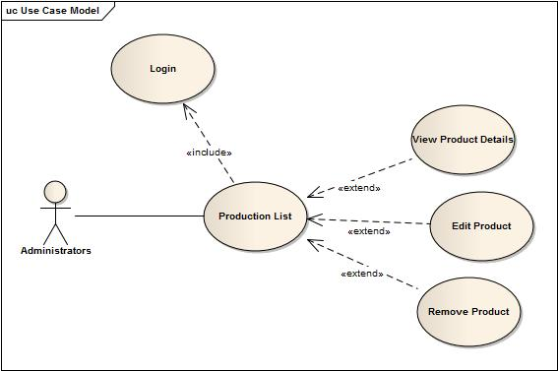

|  |  |  |
| --- | --- | --- |
| Author | Trần Minh Phát | |
| Use Case Name |  | |
| Actors | Administrators | |
| Description | Administrator wish to view list of products | |
| Requirements |  | |
| Pre-conditions | Actor has logged in as Administrator | |
| Post-conditions | Success: List of production show successful | |
| Basic flow | Actor Actions:  1. Actor clicks ‘Quản Lý Sản Phẩm’ menu on Admin page | System Responses:  2. System redirects to View List of Production page and displays form for Actor :  -‘ID’ label  -‘Name’ label  -‘Categories’ label  -‘Brand’ label  -‘Price’ label  -‘Quantity’ label  -‘Image’ label  -‘Order Count’ label  -‘Action’ dropdown list |
| Alternative flow | Actor Actions:   1. Actor clicks Action Drop down list on View list of productions page 2. Actor choose ‘Edit/Remove’ action 3. Actor click in Production’s name | System Responses:  1. Actor choose Edit then System redirect to Production Edit page.  2. Actor do Remove action a pop-up show up and message actor that System that will remove Orders, Comment of that Production. System deleted Production from database then display message ‘Your production has been delete successful’.  3. System will redirect to Production details page. |
| Exception flow |  |  |

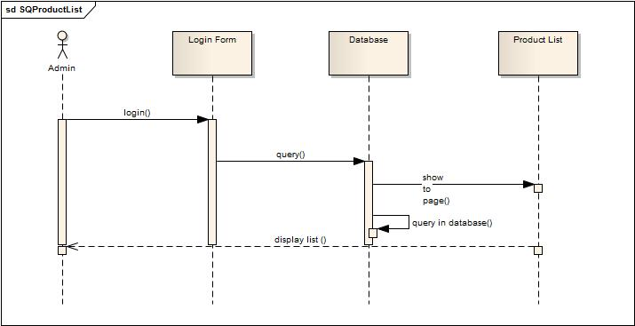

* + 1. Manager category

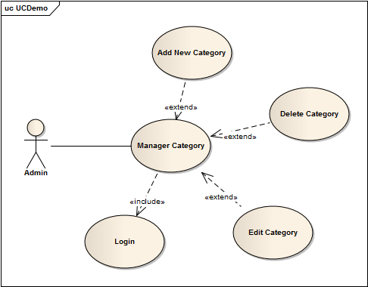

|  |  |  |
| --- | --- | --- |
| Author | Trần Đức Hoà | |
| Use Case Name | Manager Category | |
| Actors | Administrators | |
| Description | View list Categories | |
| Requirements |  | |
| Pre-conditions | Logged in as a Administrator. | |
| Post-conditions | Success : View all Categories | |
| Basic flow | Actor actions:   * From Administrator page click at Manager Category of Menu left. | Web Page response:  -Go to List Category page and display all categories .   * With :   + Category Name  + Status (still or empty)  + Category Sub  + Combo box with Edit Category and Delete Category.  + Add new category button. |
| Alternative flow | * Click Add new category button. * Choice Edit category * Choice detele category . | * Go to Add category page. * Go to Edit category page. * System show a message Yes or No.   + If choice Yes : Category has been deleted.  + If choice No : Cancel |
| Exception flow |  |  |

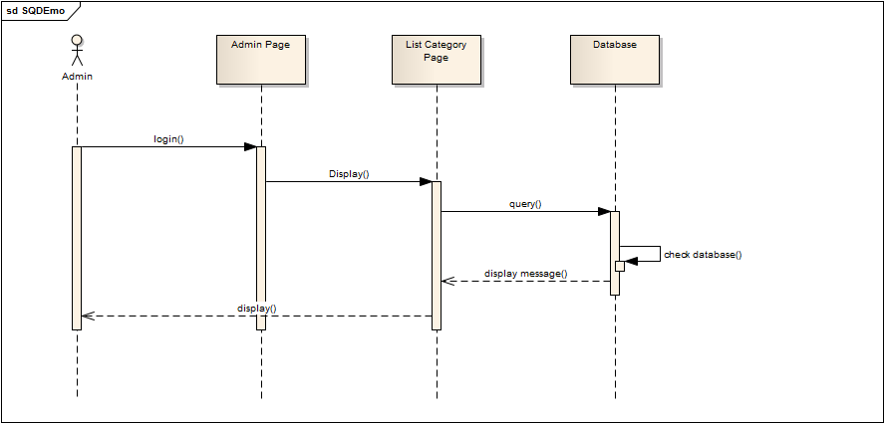

* + 1. Manager brand

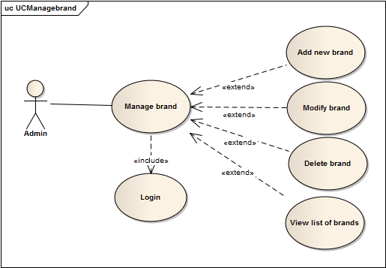

|  |  |  |
| --- | --- | --- |
| Author | Lương Tấn Chức | |
| Use Case Name | Manager Brand | |
| Actors | Administrators | |
| Description | Administrator wish to view list Manager Brand | |
| Requirements |  | |
| Pre-conditions | Actor has logged in as Administrator | |
| Post-conditions | Success: List of Manager Brand show successful | |
| Basic flow | Actor Actions:  1. Actor clicks ‘Manager Brand’ button on Admin page | System Responses:  2. System redirects to View List of Brand page and displays form for Actor :  -‘Name’ label  -‘Add’ button  -‘Modify’ button  -‘Delete’ button  -‘Cancel’ button  [Alternative 1] [Alternative 2] [Alternative 3] [Alternative 4] |
| Alternative flow | Manager Brand page  [Alternative 2]  Actor clicks ‘Modify’ button on View List of Brand page  Actor click ‘Cancel’ button  [Alternative 3]  Actor clicks Activate button on View List of Manager Brand page  [Alternative 4]  Actor clicks Delete button on View List of Manager Brand page | System redirects to Modify Brand page  System redirects to View List Manager Brand page.  System change status of Manager Brand to deactivate and change label of button to Deactivate  View in Delete Manager Brand |
| Exception flow |  |  |

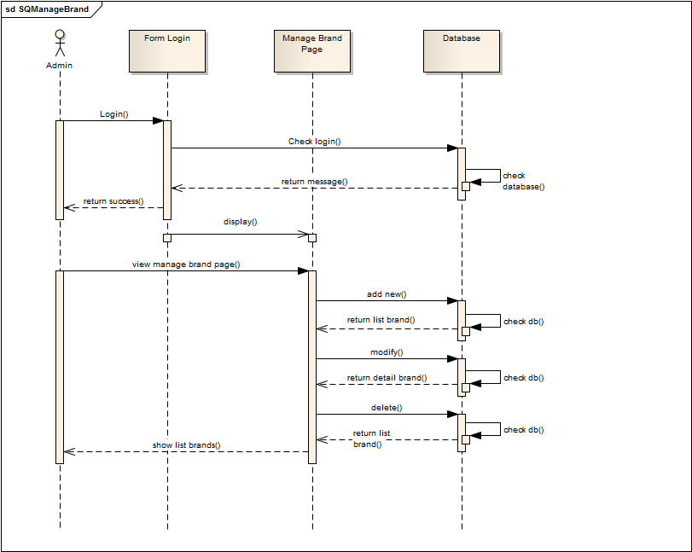

* + 1. Manager news category

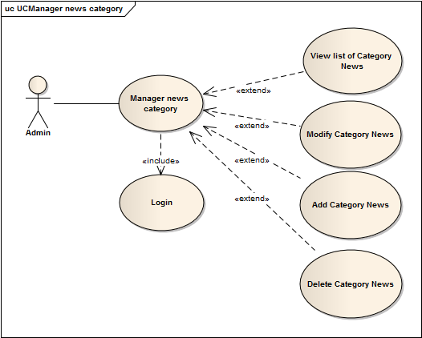

|  |  |  |
| --- | --- | --- |
| Author | Lương Tấn Chức | |
| Use Case Name | Manager news category | |
| Actors | Administrators | |
| Description | Administrator wish to view list Manager news category | |
| Requirements |  | |
| Pre-conditions | Actor has logged in as Administrator | |
| Post-conditions | Success: User logged in to website.  Fail: Refill information | |
| Basic flow | Actor Actions:  1. Actor clicks ‘Manager news category’ button on Admin page | System Responses:  2. System redirects to View List of news category page and displays form for Actor :  -‘ID’ label  ­-‘Name’ label  -Quantity of news  -‘Add’ button  -‘Modify’ button  -‘Delete’ button  [Alternative 1] [Alternative 2] [Alternative 3] [Alternative 4] |
| Alternative flow | Manager news category page  [Alternative 2]  Actor clicks ‘Modify’ button on View List of news category page  Actor click ‘Cancel’ button  Actor click ‘OK’ button  [Alternative 3]  Actor clicks Add button on View List of news category page  [Alternative 4]  Actor clicks Delete button on View List of news category page | System redirects to View modify news category page  System redirects to View modify news category page  System redirects to View modify news category page  System add new category of news  View in Delete news category |
| Exception flow |  |  |

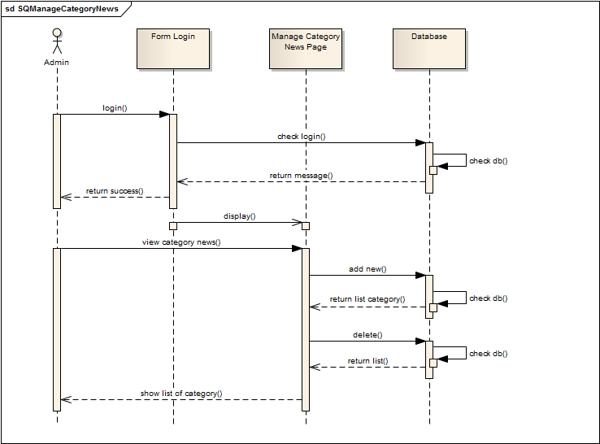

* + 1. Manager news

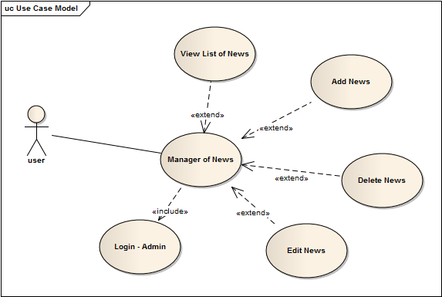

|  |  |  |
| --- | --- | --- |
| Author | Phạm Tân Yên | |
| Use Case Name | Manager news | |
| Actors | Administrators | |
| Description | View list of news | |
| Requirements |  | |
| Pre-conditions | Already login into the System as Administrator | |
| Post-conditions | Success: View List of news | |
| Basic flow | Actor actions:  1. From ‘Admin’ page, actor clicks on to the ‘Manager of News’ button. | System response:  2. System redirects to ‘List of News’ page and display list of all of News in table form with control :  ‘NewsID’ label  ‘NewsTitle’ label  ‘Date’ label  ‘Detail’ button  ‘Delete’ button  ‘Edit’ button  ‘Add News’ button |
| Alternative flow |  |  |
| Exception flow |  |  |

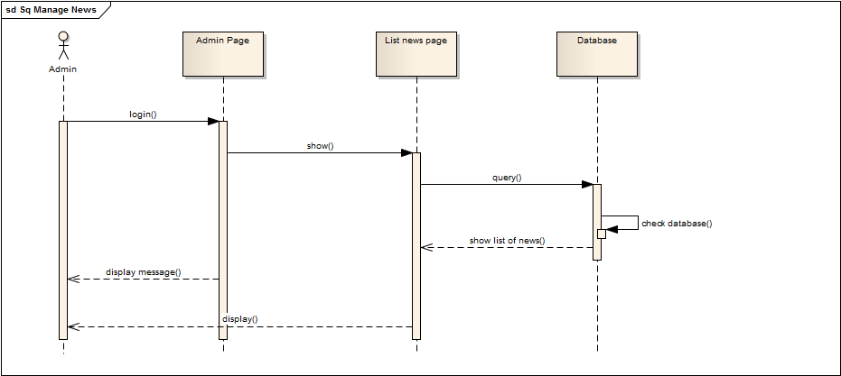

* + 1. Add news

|  |  |  |
| --- | --- | --- |
| Author | Phạm Tân Yên | |
| Use Case Name | Add news | |
| Actors | Administrators | |
| Description | Add a news | |
| Requirements |  | |
| Pre-conditions | Already login into the System as Administrator | |
| Post-conditions | Success: A News is added into the database. | |
| Basic flow | Actor actions:  1. From ‘View List of News’ page, actor clicks on to the ‘Add News’ button  3. Actor:   * Inputs Title into ‘NewsTitle’ textfield. * Inputs Content into ‘NewContent’ textfield. * Inputs image into ‘New image’ textfield. * Select NewsCate in ‘NewCateName’ Combobox   Clicks on to ‘Add’ button to finish adding. [Alternative 1] | System response:  2. System redirects to ‘Add News’ page and display form with the following controls:  ‘NewTitle’ Textfield  ‘NewContent’ Textfield  ‘NewImage’ Textfield  ‘NewCateName’ Combobox |
| Alternative flow | [Alternative 1]  1. Actor clicks on to ‘Cancel’ button | 1. System redirects to ‘View List of News’ page |
| Exception flow | [Exception 1]  1. Actor lefts ‘NewTitle’ textfield.  2. Actor lefts ‘News Content’ textfield. | System displays a message to notice actor:  “News Title cannot be blank. Please input News Title.”  “Content cannot be blank. Please input Content.” |

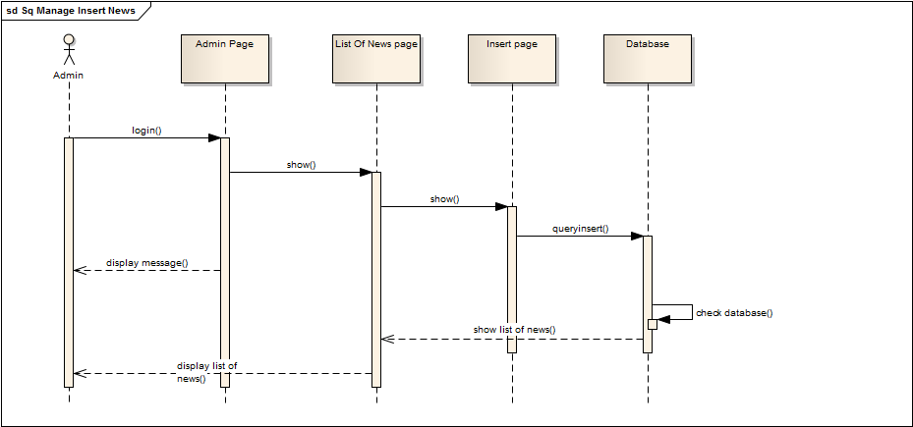

* + 1. Edit news

|  |  |  |
| --- | --- | --- |
| Author | Phạm Tân Yên | |
| Use Case Name | Edit news | |
| Actors | Administrators | |
| Description | Edit a news | |
| Requirements |  | |
| Pre-conditions | Already login into the System as Administrator | |
| Post-conditions | Success: A News is edited into the database. | |
| Basic flow | Actor actions:  1. From ‘View List of News’ page, actor clicks on to the ‘Edit’ button  3. Actor:   * Inputs Title into ‘NewsTitle’ textfield. * Inputs Content into ‘NewContent’ textfield. * Inputs image into ‘New image’ textfield. * Select NewsCate in ‘NewCateName’ Combobox   Clicks on to ‘Save’ button to finish adding. [Alternative 1] | System response:  2. System redirects to ‘Edit News’ page and display form with the following controls:  ‘NewTitle’ Textfield  ‘NewContent’ Textfield  ‘NewImage’ Textfield  ‘NewCateName’ Combobox |
| Alternative flow | [Alternative 1]  1. Actor clicks on to ‘Cancel’ button | 1. System redirects to ‘View List of Questions’ page |
| Exception flow | [Exception 1]  1. Actor lefts ‘NewTitle’ textfield.  2. Actor lefts ‘News Content’ textfield. | System displays a message to notice actor:  “News Title cannot be blank. Please input News Title.”  “Content cannot be blank. Please input Content.” |

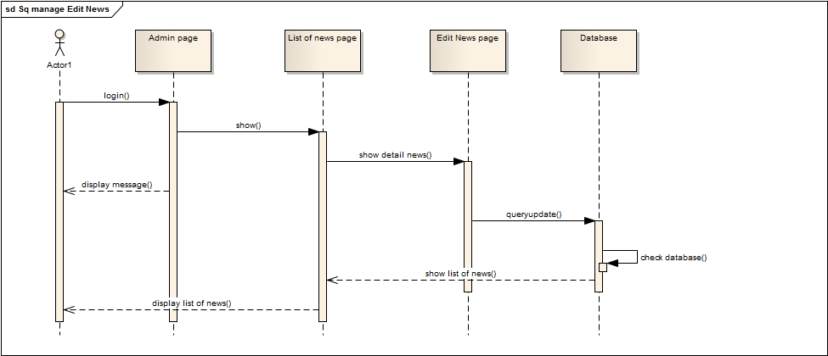

* + 1. Delete news

|  |  |  |
| --- | --- | --- |
| **Author** | Phạm Tân Yên | |
| **Use case name** | Delete News | |
| **Actors** | Administrator | |
| **Description** | Delete a News | |
| **Requirements** |  | |
| **Pre-conditions** | Already login into the System as Administrator | |
| **Post-conditions** | Success: A News is deleted in the database. | |
| **Basic flow** | Actor actions:  1. From ‘List of News’ page, actor clicks on to the ‘Delete’ hyperlink of News which actor wants to delete.  3. Actor clicks ‘Yes’ button.[Alternative 1] | System response:  2. A confirms message box appears:”Do you want to delete this News?”  4. System deletes the question in the database. |
| **Alternative flow** | [Alternative 1]  1. Actor clicks on to ‘No’ button | 2. System redirects to ‘List of News’ page |
| **Exception** |  |  |

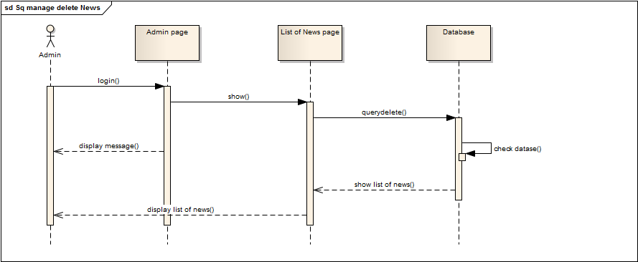

* + 1. Manager comment

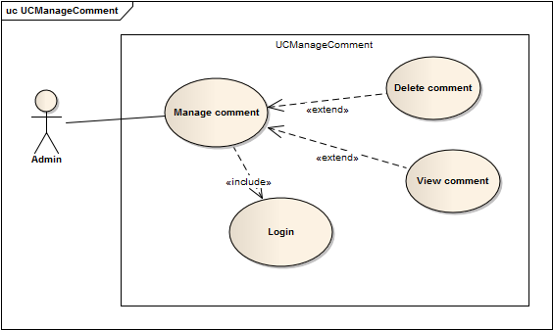

|  |  |  |
| --- | --- | --- |
| Author | Đoàn Đình Huy | |
| Use Case Name | Manager Comment | |
| Actors | Administrators | |
| Description | Administrator wish to view list of comments | |
| Requirements |  | |
| Pre-conditions | Actor has logged in as Administrator | |
| Post-conditions | Success: List of bank show successful | |
| Basic flow | Actor Actions:  1. Actor clicks ‘Managing Comments’ button on Admin page | System Responses:  2. System redirects to View List of Comments page and displays form for Actor :  -‘ID’ label  -‘User’s name’ label  -‘Product name’ label  -‘Content’ label  -‘Action’ button |
| Alternative flow | Actor Actions:   1. Actor clicks Action button on View list of comments page   3. Actor clicks Yes button on popup message | System Responses:   1. System show popup message :”Do you want to remove this comment ? ”. With Yes and No button   4. System delete bank from database then display message ‘Your bank has been delete successful’. |
| Exception flow |  |  |

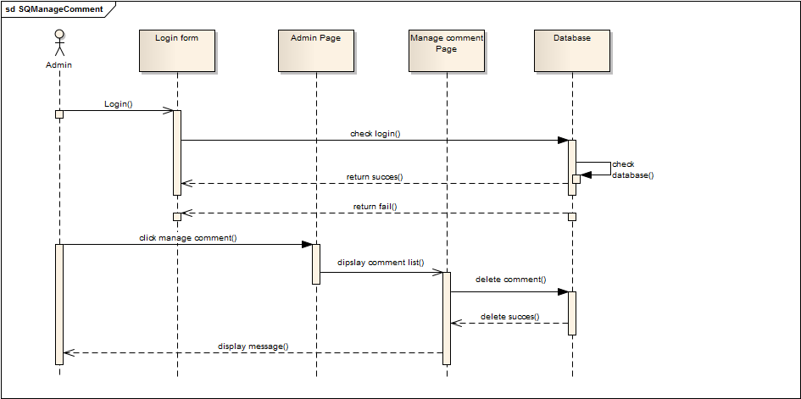

* + 1. Add Comment



|  |  |  |
| --- | --- | --- |
| Author | Đoàn Đình Huy | |
| Use Case Name | Add comment | |
| Actors | User | |
| Description | User want to comment on a product on Home Page. | |
| Requirements | Actor must view detail of product | |
| Pre-conditions | Actor has logged in as User | |
| Post-conditions | Success: comment will show on comment field  Fail: Refill information | |
| Basic flow | Actor Actions:  -Actor clicks ‘Write comment’ tab on View product detail page  -Actor input comment and click button ‘Send’ | System Responses:  -System redirects to this page and displays form for Actor to input comment  -System will send Actor’s comment to Admin’s page so Admin can view Actor’s comment. |
| Alternative flow |  |  |
| Exception flow |  |  |



# Entity Relationship Diagram (ERD)

## ERD

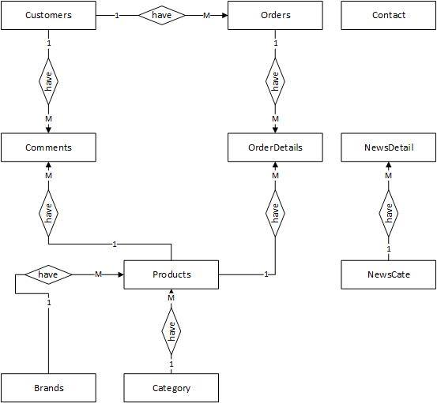

## Entity

* + 1. Customer Entity

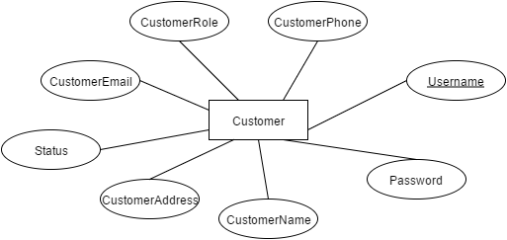

* + 1. Brands Entity

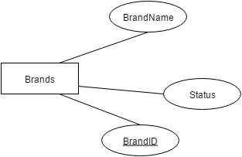

* + 1. CategoryEntity

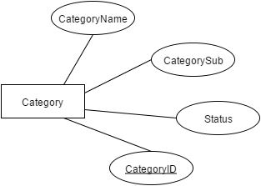

* + 1. Product Entity

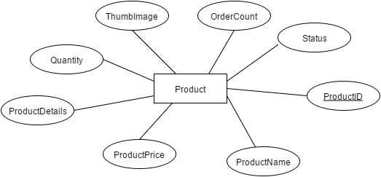

* + 1. Comments Entity

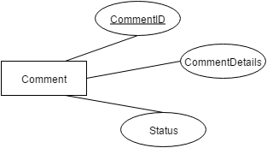

* + 1. NewsCate Entity

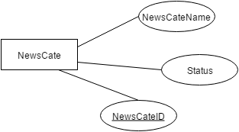

* + 1. NewsDetail Entity

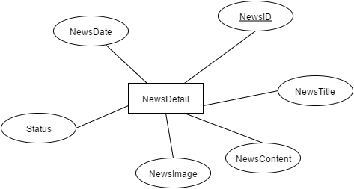

* + 1. Contact Entity

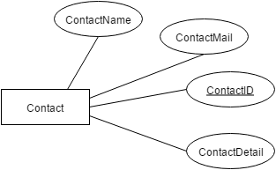

* + 1. Order Entity

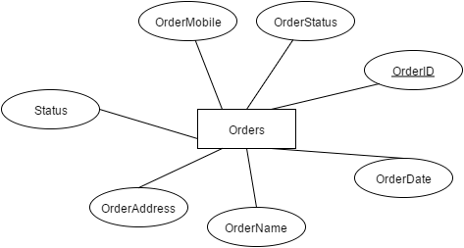

* + 1. OrderDetail Entity

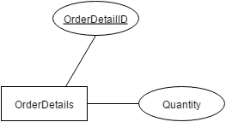

# Task Sheet

|  |  |  |  |  |  |
| --- | --- | --- | --- | --- | --- |
| Members | | Task | Date | | Status |
| No | Full Name |  | Start Date | Date Finish |  |
| 1. | Nguyễn Cảnh Khánh Trình | Joint working | 7/8/2015 | 13/8/2015 | Completed |
| 2. | Lương Tấn Chức | Joint working | Completed |
| 3. | Phạm Tân Yên | Joint working | Completed |
| 4. | Trần Minh Phát | Joint working | Completed |
| 5 | Trần Đức Hoà | Joint working | Completed |
| 6 | Đoàn Đình Huy | Joint working | Completed |

|  |  |
| --- | --- |
| Leader | Faculty |
|  |  |
| Nguyễn Cảnh Khánh Trình | Dương Trọng Phú Sơn |

**REVIEW 3**

# Database Relationship Diagram

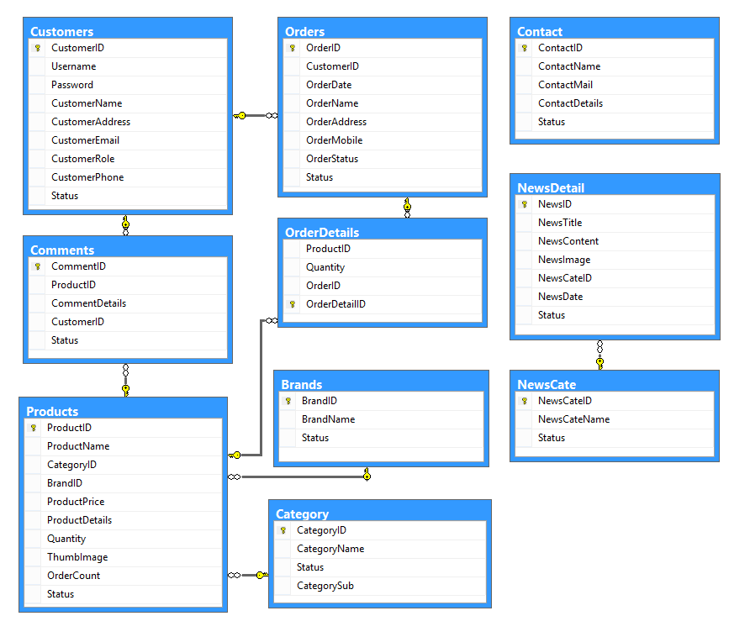

# Table Definition

## Product

|  |  |  |  |  |  |  |  |
| --- | --- | --- | --- | --- | --- | --- | --- |
| **Key** | **Field Name** | **Data Type** | **Length** | **Allow Null** | **Default value** | **Table-Field-Ref** | **Description** |
| PK | **ProductID** | Int |  | No |  |  | Product ID  Identity |
|  | ProductName | nvarchar | 200 | No |  |  | Product Name |
| FK | CategoryID | Int |  | No |  |  | Category ID  Foreign Key of Category Tables |
| FK | BrandID | Int |  | NO |  |  | Brand ID  Foreign Key of Brand Tables |
|  | ProductPrice | Bigint |  | No |  |  | Price Of Product |
|  | ProductDetails | Ntext |  | Yes |  |  | Details of Product |
|  | Quantity | Int |  | No |  |  | Inventory of product |
|  | ThumbImage | Varchar | 200 | Yes |  |  | Name of Product Image |
|  | OrderCount | Int |  | No |  |  | Count Number of product that has ordered |

Contrainst:

|  |  |  |  |  |
| --- | --- | --- | --- | --- |
| **Name** | **Create** | **Remove** | **Update** | **Details** |
| Product | + | + | + | + |

## Brand

|  |  |  |  |  |  |  |  |
| --- | --- | --- | --- | --- | --- | --- | --- |
| **Key** | **Field Name** | **Data Type** | **Length** | **Allow Null** | **Default value** | **Table-Field-Ref** | **Description** |
| PK | **BrandID** | Int |  | No |  |  | Brand ID  Identity |
|  | BrandName | Nvarchar | 30 | No |  |  | Brand Name |

Contrainst:

|  |  |  |  |  |
| --- | --- | --- | --- | --- |
| **Name** | **Create** | **Remove** | **Update** | **Details** |
| Brand | + | + | + | + |

* 1. Category

|  |  |  |  |  |  |  |  |
| --- | --- | --- | --- | --- | --- | --- | --- |
| **Key** | **Field Name** | **Data Type** | **Length** | **Allow Null** | **Default value** | **Table-Field-Ref** | **Description** |
| PK | **CategoryID** | Int |  | No |  |  | CategoryID  Identity |
|  | CategoryName | Nvarchar | 30 | No |  |  | Category Name |

Contrainst:

|  |  |  |  |  |
| --- | --- | --- | --- | --- |
| **Name** | **Create** | **Remove** | **Update** | **Details** |
| Brand | + | + | + | + |

* 1. Comment

|  |  |  |  |  |  |  |  |
| --- | --- | --- | --- | --- | --- | --- | --- |
| **Key** | **Field Name** | **Data Type** | **Length** | **Allow Null** | **Default value** | **Table-Field-Ref** | **Description** |
| PK | **CommentID** | Int |  | No |  |  | CommentID  Identity |
| FK | ProductID | int | 30 | No |  |  | Product ID |
|  | CommentDetails | Ntext |  | No |  |  | Content Comment |
| FK | CustomerID | Int |  | No |  |  | Customer ID |

Contrainst:

|  |  |  |  |  |
| --- | --- | --- | --- | --- |
| **Name** | **Create** | **Remove** | **Update** | **Details** |
| Comment | + | + | + | + |

* 1. Contact

|  |  |  |  |  |  |  |  |
| --- | --- | --- | --- | --- | --- | --- | --- |
| **Key** | **Field Name** | **Data Type** | **Length** | **Allow Null** | **Default value** | **Table-Field-Ref** | **Description** |
| PK | **ContactID** | Int |  | No |  |  | ContactID  Identity |
|  | ContactName | Nvarchar | 50 | No |  |  | Contact Name |
|  | ContactMail | Nvarchar | 50 | No |  |  | Contact Mail |
|  | ContactDetails | ntext |  | No |  |  | Content Contact |

Contrainst:

|  |  |  |  |  |
| --- | --- | --- | --- | --- |
| **Name** | **Create** | **Remove** | **Update** | **Details** |
| Contact | + | + | + | + |

* 1. Customer

|  |  |  |  |  |  |  |  |
| --- | --- | --- | --- | --- | --- | --- | --- |
| **Key** | **Field Name** | **Data Type** | **Length** | **Allow Null** | **Default value** | **Table-Field-Ref** | **Description** |
| PK | **CustomerID** | Int |  | No |  |  | CustomerID  Identity |
|  | UserName | varchar | 30 | No |  |  | User Name |
|  | Password | varchar | 20 | No |  |  | Password |
|  | CustomerName | Nvarchar | 60 | No |  |  | Customer Name |
|  | CustomerAddress | Nvarchar | 200 | No |  |  | User’s Address |
|  | CustomerEmail | Varchar | 100 | Yes |  |  | User’s Email |
|  | CustomerRole | Varchar | 10 | Yes |  |  | Role |
|  | CustomerPhone | Varchar | 20 | Yes |  |  | User’s Phone |

Contrainst:

|  |  |  |  |  |
| --- | --- | --- | --- | --- |
| **Name** | **Create** | **Remove** | **Update** | **Details** |
| Customer | + | + | + | + |

* 1. News Category

|  |  |  |  |  |  |  |  |
| --- | --- | --- | --- | --- | --- | --- | --- |
| **Key** | **Field Name** | **Data Type** | **Length** | **Allow Null** | **Default value** | **Table-Field-Ref** | **Description** |
| PK | **NewsCateID** | Int |  | No |  |  | News Category ID  Identity |
|  | NewsCateName | nvarchar | 200 | No |  |  | Name Category |

Contrainst:

|  |  |  |  |
| --- | --- | --- | --- |
| **Name** | **Add** | **Delete** | **Update** |
| News Category | + | + | + |

* 1. News Detail

|  |  |  |  |  |  |  |  |
| --- | --- | --- | --- | --- | --- | --- | --- |
| **Key** | **Field Name** | **Data Type** | **Length** | **Allow Null** | **Default value** | **Table-Field-Ref** | **Description** |
| PK | **NewsID** | int |  | No |  |  | News ID  Identity |
|  | NewsTitle | nvarchar | 200 | No |  |  | News Title |
|  | NewsContent | Ntext |  | No |  |  | News content |
|  | NewsImage | Nvarchar | 200 | No |  |  | News Image |
| FK | NewsCateID | Int |  | No |  |  | News Category ID |
|  | NewsDate | DateTime |  | No |  |  | News Date |

Contrainst:

|  |  |  |  |
| --- | --- | --- | --- |
| **Name** | **Add** | **Delete** | **Update** |
| News Detail | + | + | + |

* 1. Orders

|  |  |  |  |  |  |  |  |
| --- | --- | --- | --- | --- | --- | --- | --- |
| **Key** | **Field Name** | **Data Type** | **Length** | **Allow Null** | **Default value** | **Table-Field-Ref** | **Description** |
| PK | **OrderID** | int |  | No |  |  | Order ID  Identity |
| FK | CustomerID | Int |  | No |  |  | Customer ID |
|  | OrderDate | Datetime |  | No |  |  | Order Date |
|  | OrderName | Nvarchar | 100 | No |  |  | Order Name |
|  | OrderAddress | Nvarchar | 200 | No |  |  | Order Address |
|  | OrderMobile | Nvarchar | 12 | No |  |  | Order Mobile |
|  | OrderStatus | Smallint |  | Yes |  |  | Status |

Contrainst:

|  |  |  |  |
| --- | --- | --- | --- |
| **Name** | **Add** | **Delete** | **Update** |
| News Detail | + | + | + |

* 1. OrderDetails

|  |  |  |  |  |  |  |  |
| --- | --- | --- | --- | --- | --- | --- | --- |
| **Key** | **Field Name** | **Data Type** | **Length** | **Allow Null** | **Default value** | **Table-Field-Ref** | **Description** |
| PK | **OrderDatilID** | int |  | No |  |  | Order detail ID  Identity |
| FK | ProductID | Int |  | No |  |  | Product ID |
|  | Quantity | Smallint |  | No |  |  | Quantity |
| FK | OrderID | Int |  | No |  |  | Order ID |

Contrainst:

|  |  |  |  |
| --- | --- | --- | --- |
| **Name** | **Add** | **Delete** | **Update** |
| Orderdetail | + | + | + |

# Sitemap

## Admin Page

Login

Admin Home

Delet

Add Product

Update

List Product

List Invoice

List Brand

Add

Update

Delete

System Statitics

List Customer

Delete

Update

Add

List News

Delete

Update

Add

News Cate

## User Page

Home Page

Login

Register

Product Detail

My Account

Profile

Change Profile

Change Pass

Search

Category

FeedBack

About us

Checkout

Cart

Logout

# GUI Design

## User page

### Register Page

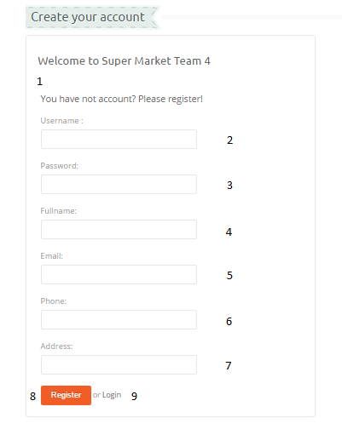

|  |  |  |  |  |  |  |
| --- | --- | --- | --- | --- | --- | --- |
| No. | Name | Type | Validation | Event | Description | Status |
| 1 | gridRegister | Grid |  |  | Grid contains controls: 2, 3, 4, 5, 6, 7, 8, 9, |  |
| 2 | txtUsername | Text field | 6<=length<=30  Not exist in the database |  | Username |  |
| 3 | txtPassword | Text field | 0<length<=30 |  | User’s Password |  |
| 4 | txtFullname | Text field | 0<length<=60 |  | User’s Name |  |
| 5 | txtEmail | Text field | 0<length<=100  /.+@.+\.[a-z]+/ |  | User’s Email |  |
| 6 | ibPhone | Text field | 10<length<=11  [0-9] |  | User’s Phone |  |
| 7 | txtAddress | Text field | 0<length<=200 |  | User’s Address |  |
| 8 | btnRegister | Button |  | Click | Register user with the system and redirect to home page |  |
| 9 | btnLogin | Button |  | Click | Back to Login page |  |

### Login Page

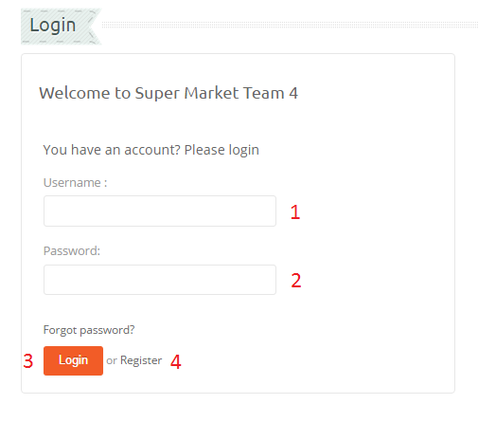

|  |  |  |  |  |  |  |
| --- | --- | --- | --- | --- | --- | --- |
| No. | Name | Type | Validation | Event | Description | Status |
| 1 | txtUserName | Text field | Not null |  | User name |  |
| 2 | txtPassword | Text field | Not null |  | Password |  |
| 3 | btnLogin | Button |  | Click | Login to the system and redirect to User’s Home page |  |
| 4 | btnRegister | Button |  | Click | Back to Register page |  |

### Product Page

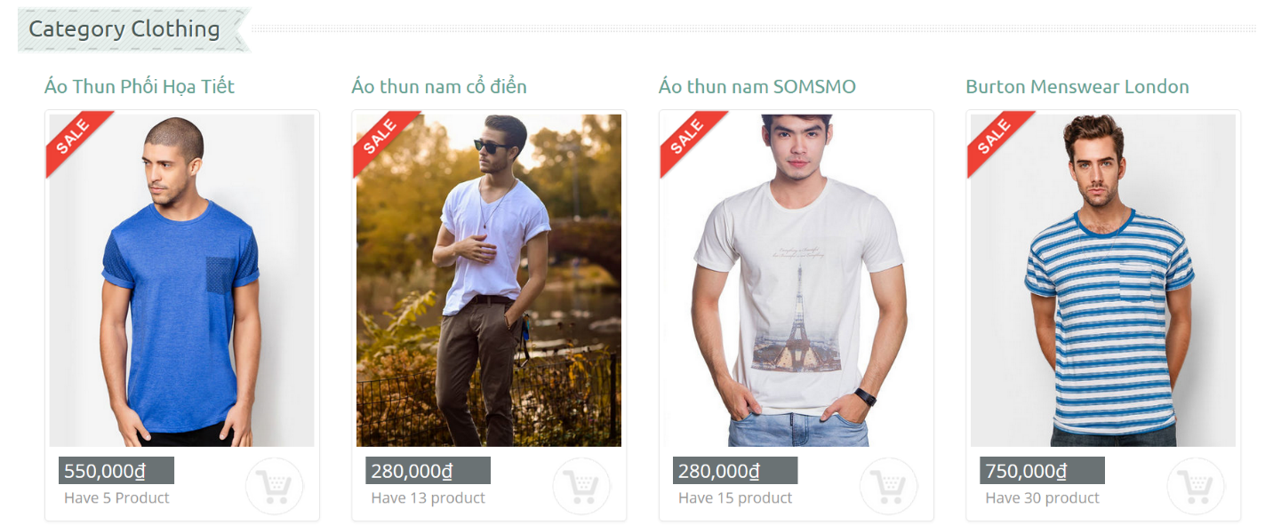

|  |  |  |  |  |  |  |
| --- | --- | --- | --- | --- | --- | --- |
| **No.** | **Name** | **Type** | **Validation** | **Event** | **Description** | **Status** |
| 1 | Product name | Label |  |  | Name of Product |  |
| 2 | Price | Label |  |  | Product Price |  |
| 3 | Image | Image |  |  | Image of Product |  |
| 4 | Quantity | Label |  |  | Inventory of Product |  |
| 5 | Add to Cart | Input |  | Click | Quick Add Product To Cart |  |

### Product Detail Page

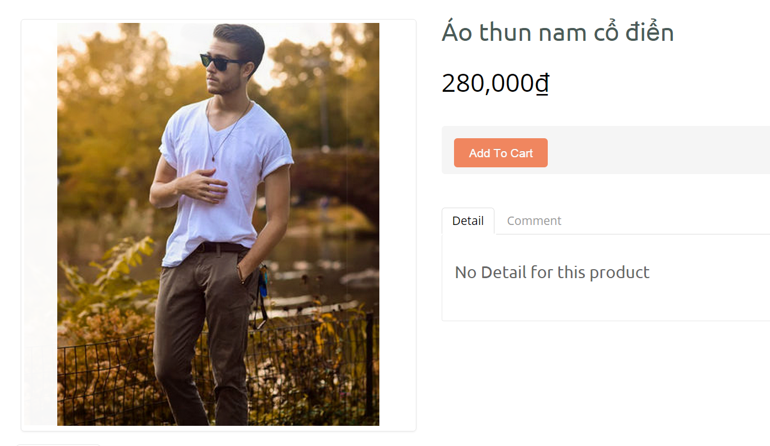

|  |  |  |  |  |  |  |
| --- | --- | --- | --- | --- | --- | --- |
| **No.** | **Name** | **Type** | **Validation** | **Event** | **Description** | **Status** |
| 1 | Product Title | Link |  | Click | Product Category>Product Details |  |
| 2 | Image | Image |  |  | Product Large image |  |
| 3 | Name | Label |  |  | Product Name |  |
| 4 | Price | Label |  |  | Product Price in Vietnam Dong |  |
| 5 | btnBuyNow | Button |  | click | Add Product To Cart |  |
| 6 | tabDetails | Tab |  |  | Product Details |  |
| 10 | tabComment | Tab |  |  | Comment of Product And Write comment for Product |  |

### Display Category

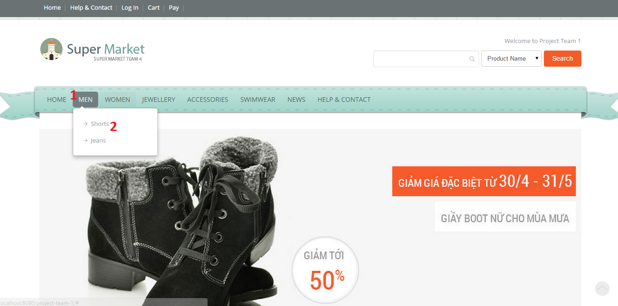

|  |  |  |  |  |  |  |
| --- | --- | --- | --- | --- | --- | --- |
| **No.** | **Name** | **Type** | **Validation** | **Event** | **Description** | **Status** |
| 1 | cmdLink | CommandLink |  | Click | Goto Page which display list of Category |  |
| 2 | cmdLink | CommandLink |  | Click | Goto Page which display list of Category |  |

### Category page

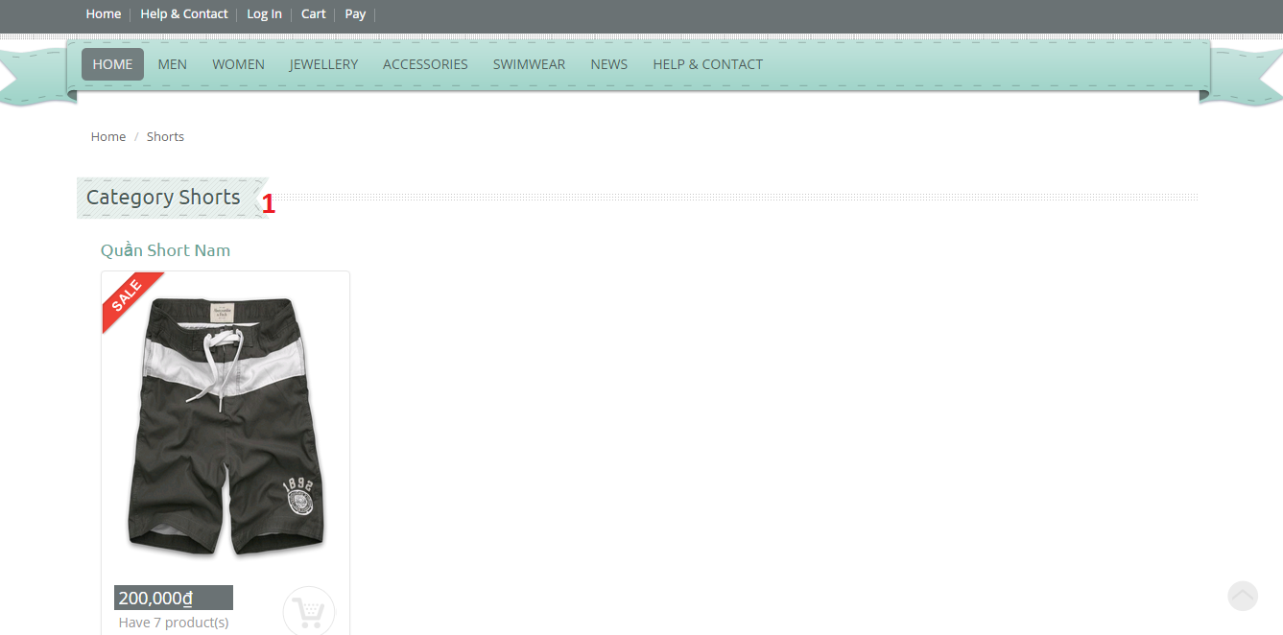

|  |  |  |  |  |  |  |
| --- | --- | --- | --- | --- | --- | --- |
| **No.** | **Name** | **Type** | **Validation** | **Event** | **Description** | **Status** |
| 1 | lbCategoryName | Label |  |  | Category’s Name |  |

### Change password

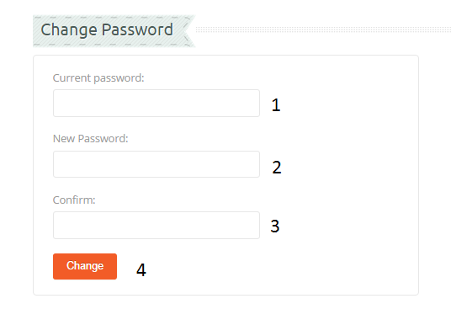

|  |  |  |  |  |  |  |
| --- | --- | --- | --- | --- | --- | --- |
| No. | Name | Type | Validation | Event | Description | Status |
| 1 | txtCurrent Password | Textfield | 3<=length<=20  Not exist in the database |  | Current Password |  |
| 2 | txtNewPassword | Passwordfield | 0<length<=20 |  | New Password |  |
| 3 | txtConfirm Password | Passwordfield | Same as txtPassword |  | Confirm password |  |
| 4 | btnChange | Button |  | Click | Change new password into database |  |

### Contact page

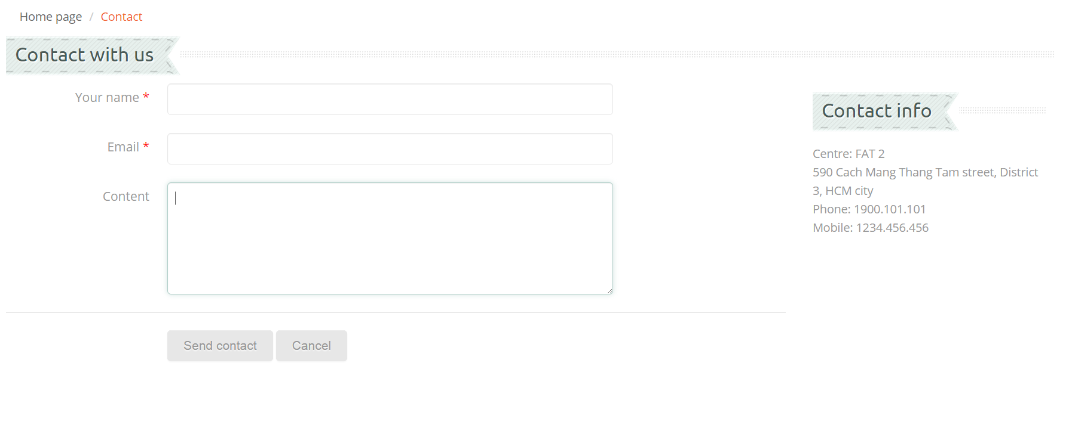

|  |  |  |  |  |  |  |
| --- | --- | --- | --- | --- | --- | --- |
| **No.** | **Name** | **Type** | **Validation** | **Event** | **Description** | **Status** |
| 1 | txtName | Text field | 0<length<=30 |  | User’s Name |  |
| 2 | txtEmail | Text field | 0<length<=30  /.+@.+\.[a-z]+/ |  | User’s email |  |
| 3 | txtContent | Text field | 0<length<=100 |  | Content of feedback |  |
| 4 | btnSend | Button |  | Click | Send Contact to admin |  |
| 5 | btnCancel | Button |  | Click | Clear content field |  |

### Comment page

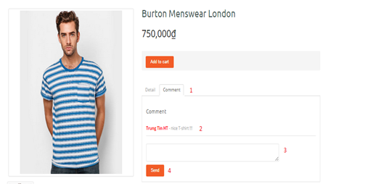

|  |  |  |  |  |  |  |
| --- | --- | --- | --- | --- | --- | --- |
| **No.** | **Name** | **Type** | **Validation** | **Event** | **Description** | **Status** |
| 1 | grdComment | Grid |  |  | Grid contains controls:2,3,4 data get from Comment table |  |
| 2 | lblComment | label | 0<length<=50 |  | Previous user’s comment about product |  |
| 3 | txtComment | Text field | 0<length<=50 |  | Content of comment |  |
| 4 | btnCancel | Button |  | Click | Clear content field |  |

### News page

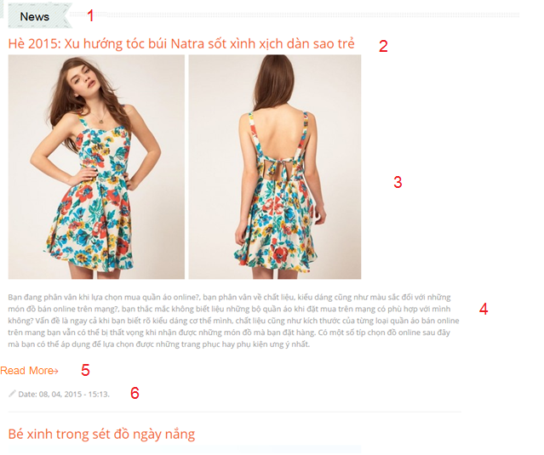

|  |  |  |  |  |  |  |
| --- | --- | --- | --- | --- | --- | --- |
| **No.** | **Name** | **Type** | **Validation** | **Event** | **Description** | **Status** |
| 1 | lbNews | lable |  |  | News |  |
| 2 | cmlNewsTitle | commanLink |  | click | News Title -> News Detail |  |
| 3 | lbNewsImage | lable |  |  | News Image |  |
| 4 | lbNewsContent | lable |  |  | News Content |  |
| 5 | cmlReadMore | commanLink |  | click | News Title -> News Detail |  |
| 6 | lbNewsDate | lable |  |  | News Date | lbNewsDate |
| 10 | cbNewsCate | combobox |  |  | Select News Cate Name |  |
| 11 | btnNewsImage | Button |  | Click | Choose Picture |  |
| 12 | txtContent | TextArea | Not null  10<length<5000 |  | Input Content News |  |
| 13 | btnEditNews | Button |  | Click |  |  |

### News Detail Page

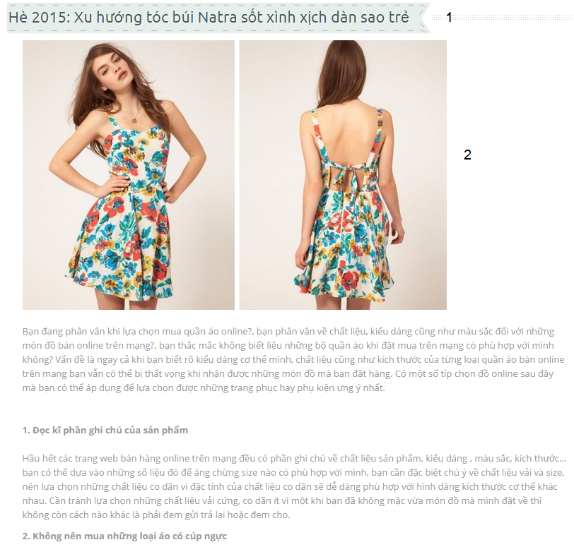

|  |  |  |  |  |  |  |
| --- | --- | --- | --- | --- | --- | --- |
| **No.** | **Name** | **Type** | **Validation** | **Event** | **Description** | **Status** |
| 1 | lbNewsTitle | lable |  |  | News TItle |  |
| 2 | lbNewsContent | lable |  | Click | News Content |  |

## Admin page

### Login page

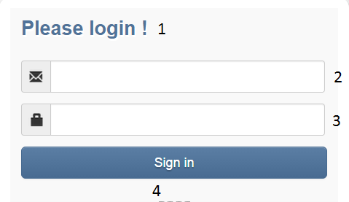

|  |  |  |  |  |  |  |
| --- | --- | --- | --- | --- | --- | --- |
| No. | Name | Type | Validation | Event | Description | Status |
| 1 | gridLogin | Grid |  |  | Grid contains controls: 2,3,4 |  |
| 2 | txtUsername | Text Field | Not null |  | Username |  |
| 3 | txtPassword | Text Field | Not null |  | Password |  |
| 4 | btnSigin | Button |  |  | Check Username and password and if they are correct, redirect to Admin Home page |  |

### Change password page

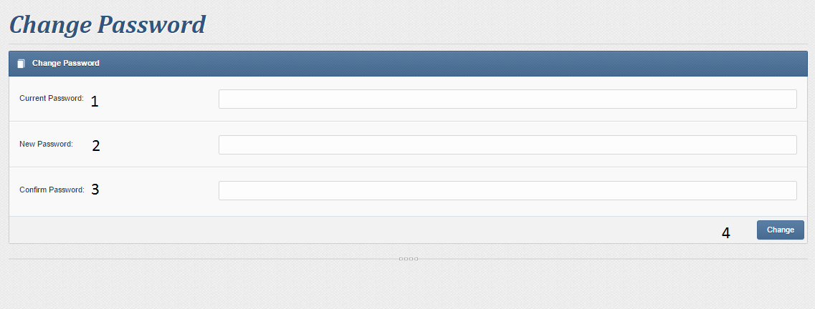

|  |  |  |  |  |  |  |
| --- | --- | --- | --- | --- | --- | --- |
| No. | Name | Type | Validation | Event | Description | Status |
| 1 | txtUsername | Textfield | 3<=length<=30  Not exist in the database |  | Admin Name |  |
| 2 | txtPassword | Passwordfield | 0<length<=30 |  | Password |  |
| 3 | txtConfirm Password | Passwordfield | Same as txtPassword |  | Confirm password |  |
| 4 | btnChange | Button |  | Click | Change new password into database |  |

### Brand manager

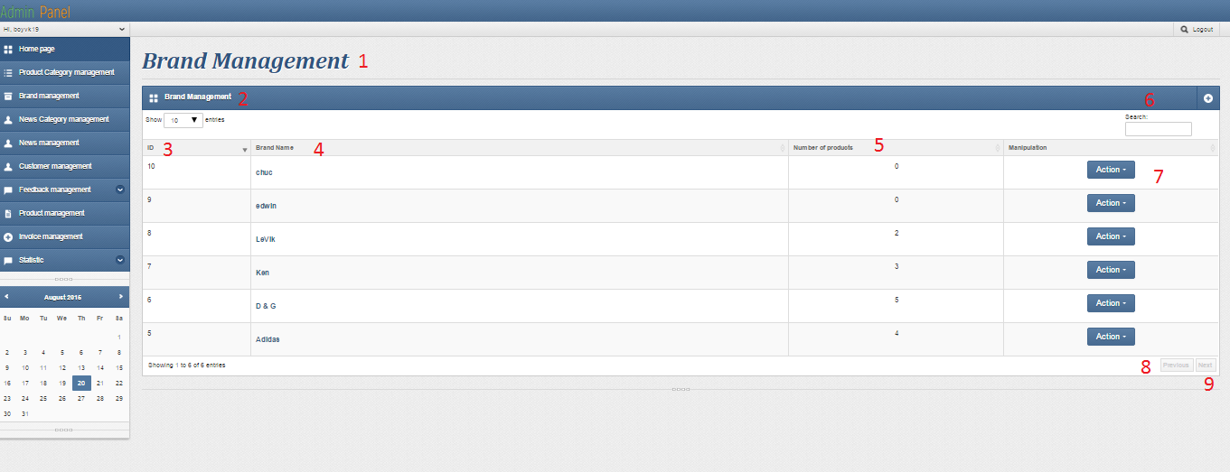

|  |  |  |  |  |  |  |
| --- | --- | --- | --- | --- | --- | --- |
| No. | Name | Type | Validation | Event | Description | Status |
| 1 | gridBrand Management | Grid |  |  | Grid contains controls: 2,3,4,5,6,7,8,9, data get from Customers table |  |
| 2 | lblBrandManagement | Label |  |  | Brand Management name |  |
| 3 | lblID | Label |  |  | Brand name ID |  |
| 4 | lblBrandname | Label |  |  | Brand Name |  |
| 5 | LblNumberofProducts | Label |  |  | Number of Products |  |
| 6 | btnAdd | Button |  | Click | Redirect to Add Brand page |  |
| 7 | btnAction | Button |  | Click | Show event edit and Delete Brand name |  |
| 8 | btnPrevious | Button |  | Click | back previous page Brand Management page |  |
| 9 | btnNext | Button |  | Click | Next page Brand Management page |  |

### Modify brand page

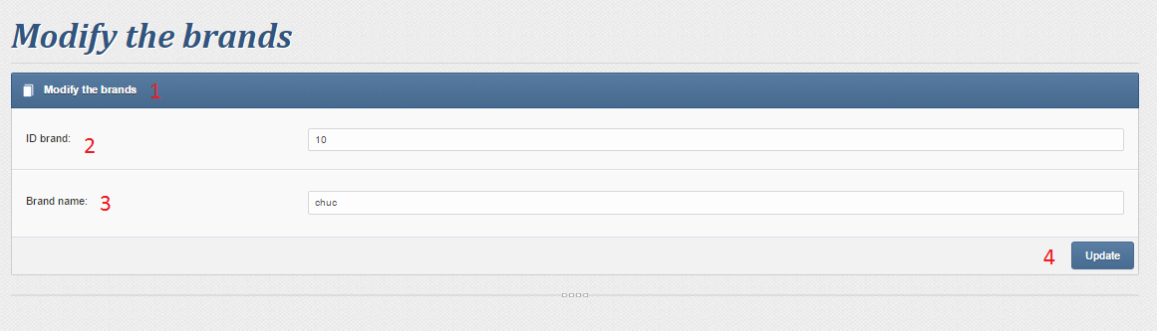

|  |  |  |  |  |  |  |
| --- | --- | --- | --- | --- | --- | --- |
| No. | Name | Type | Validation | Event | Description | Status |
| 1 | gridModifytheBrands | Grid |  |  | Grid contains controls: 2,3,4, |  |
| 2 | txtIDBrand | Textfield |  |  | Ordinal number |  |
| 3 | txtBrandname | Textfield | 3<length<=40 |  | Modify Brandname |  |
| 4 | btnUpdate | Button |  | Click | finish to modify the feature |  |

### Delete Brand page

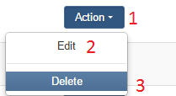

|  |  |  |  |  |  |  |
| --- | --- | --- | --- | --- | --- | --- |
| 1 | btnAction | Button |  | Click | Show event Edit and Delete Brand name |  |
| 2 | lblEdit | label |  | Click | Redirect to Modify Brandname page |  |
| 9 | lblDelete | label |  | Click | Delete Brandname |  |

### News manager

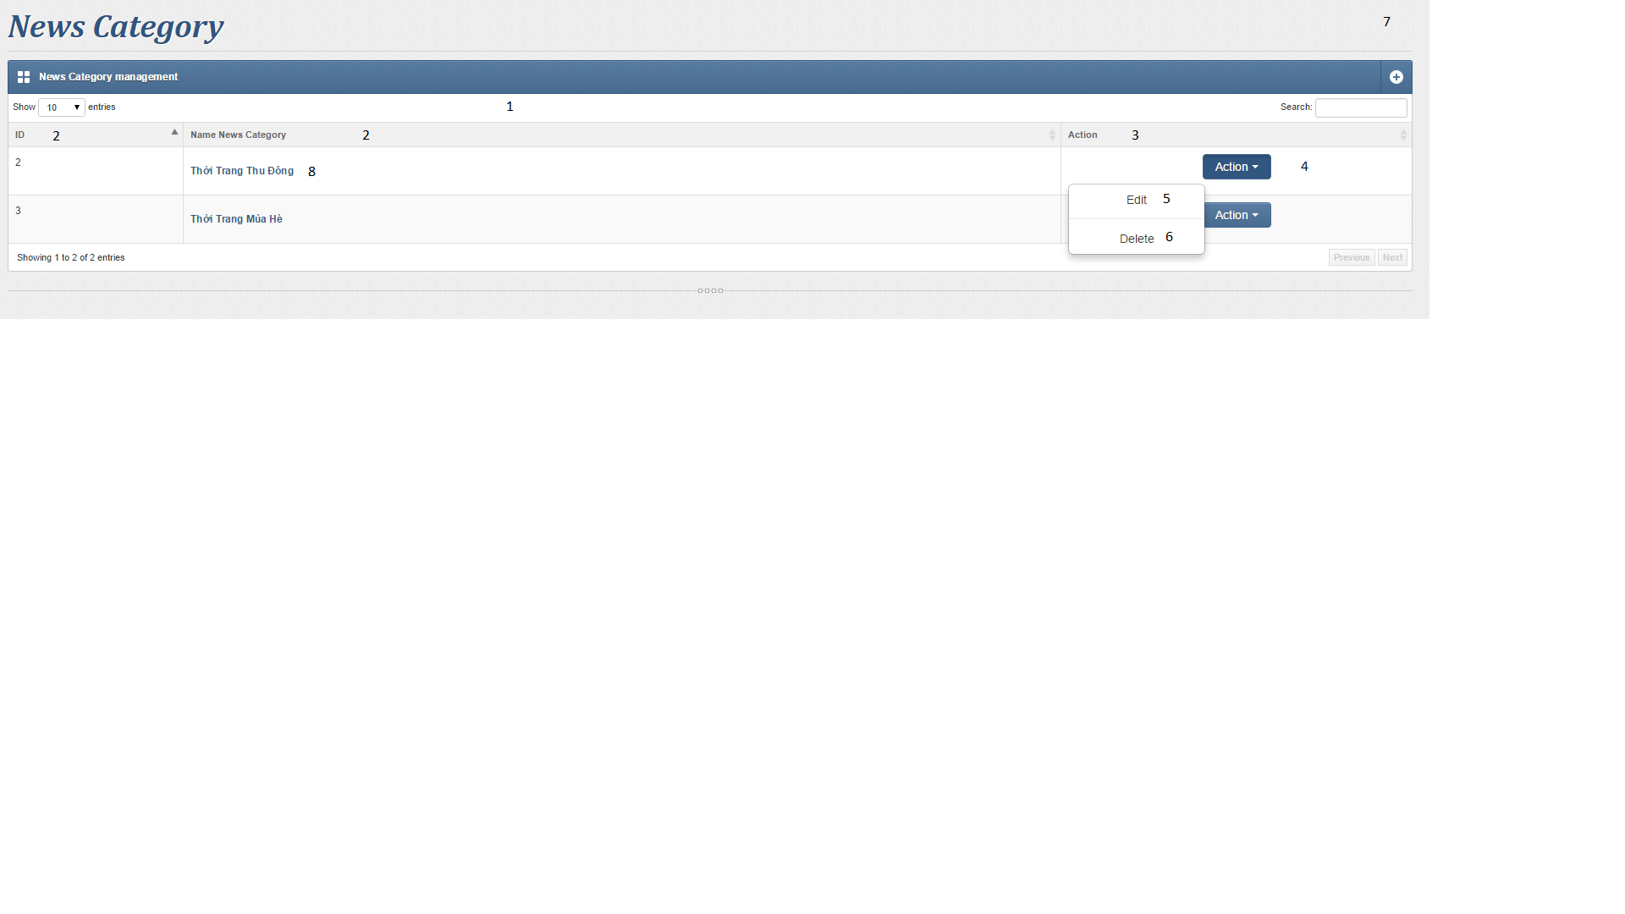

|  |  |  |  |  |  |  |
| --- | --- | --- | --- | --- | --- | --- |
| **No.** | **Name** | **Type** | **Validation** | **Event** | **Description** | **Status** |
| 1 | Table Add News Category | table |  |  |  |  |
| 2 | lbNewsCateID | Label |  |  | News Category ID |  |
| 3 | LbNewsCateName | Label |  |  | News Category Name |  |
| 4 | BtnAction | Button |  |  | Action |  |
| 5 | cmlDelete | commandLink |  | Click | Delete |  |
| 6 | cmlEdit | commandLink |  | Click | Edit |  |
| 7 | Add | Link |  | Click | Add |  |
| 8 | cmlNewsCateDetail | Link |  | Click | Show News Cate Detail |  |

### Add New

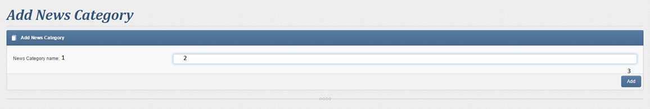

|  |  |  |  |  |  |  |
| --- | --- | --- | --- | --- | --- | --- |
| **No.** | **Name** | **Type** | **Validation** | **Event** | **Description** | **Status** |
| 1 | lbNewsCateName | lable |  |  | News Category Name |  |
| 2 | txtNewsCateName | Textfield | Not Null  0<length<=200 |  | News Category Name |  |
| 3 | btnAdd | Button |  | Click | Add news category name |  |

### Modify new category

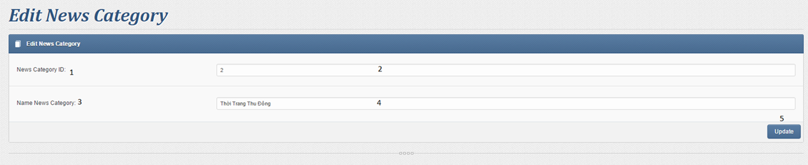

|  |  |  |  |  |  |  |
| --- | --- | --- | --- | --- | --- | --- |
| **No.** | **Name** | **Type** | **Validation** | **Event** | **Description** | **Status** |
| 1 | lbNewsCateID | lable |  |  | News Category ID |  |
| 2 | TxtNewsCateID | Textfield |  |  | News Category ID value |  |
| 1 | lbNewsCateName | lable |  |  | News Category Name |  |
| 2 | txtNewsCateName | Textfield | Not Null  0<length<=200 |  | News Category Name |  |
| 3 | btnEdit | Button |  | Click | Edit news category name |  |

### List News

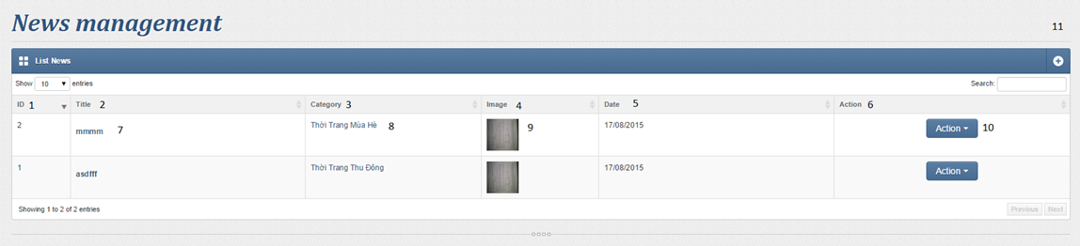

|  |  |  |  |  |  |  |
| --- | --- | --- | --- | --- | --- | --- |
| **No.** | **Name** | **Type** | **Validation** | **Event** | **Description** | **Status** |
|  | Table Add News | table |  |  |  |  |
| 1 | lbNewsID | Lable |  |  | News Category ID |  |
| 2 | lbNewsTitle | Lable |  |  | News Title |  |
| 3 | lbNewsCateName | Lable |  |  | News Category Name |  |
| 4 | lbNewsImage | Lable |  |  | News Image |  |
| 5 | lbNewsDate | Lable |  |  | News Date |  |
| 6 | lbAction | Lable |  |  | News Action |  |
| 7 | cmlNewsDetail | commandLink |  | Click | Show News Detail |  |
| 8 | cmlNewsCate | commandLink |  | Click | Show News Category Detail |  |
|  | cmlDelete | commandLink |  | Click | Delete |  |
|  | cmlEdit | commandLink |  | Click | Edit |  |

### Add News

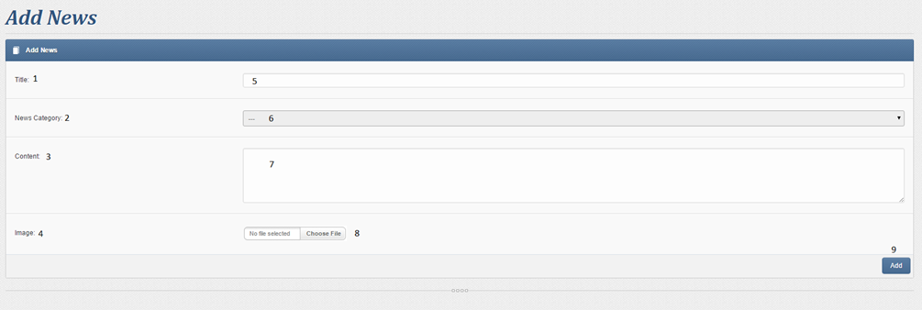

|  |  |  |  |  |  |  |
| --- | --- | --- | --- | --- | --- | --- |
| **No.** | **Name** | **Type** | **Validation** | **Event** | **Description** | **Status** |
| 1 | lbNewsTitle | lable |  |  | News Title |  |
| 2 | lbNewsCate | lable |  |  | News Category |  |
| 3 | lbNewsContent | lable |  |  | News Content |  |
| 4 | lbNewsImage | lable |  |  | News Image |  |
| 5 | txtNewsTitle | Textfield | Not null  3<length<100 |  | Input News Title |  |
| 6 | cbNewsCate | combobox |  |  | Select News Cate Name |  |
| 7 | txtContent | TextArea | Not null  10<length<5000 |  | Input Content News |  |
| 8 | btnNewsImage | Button |  | Click | Choose Picture |  |
| 9 | btnAddNews | Button |  | Click |  |  |

### Modify news

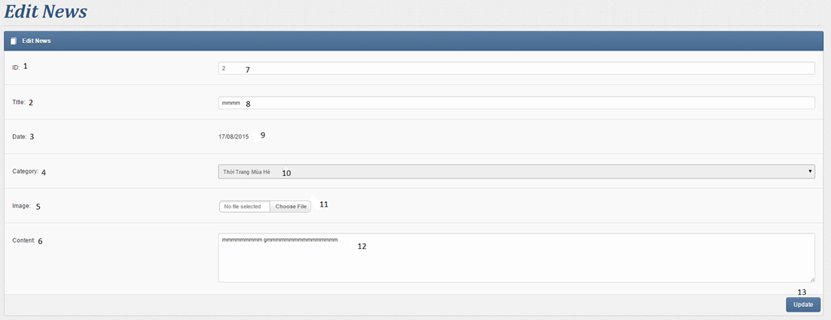

|  |  |  |  |  |  |  |
| --- | --- | --- | --- | --- | --- | --- |
| **No.** | **Name** | **Type** | **Validation** | **Event** | **Description** | **Status** |
| 1 | lbNewsID | lable |  |  | News ID |  |
| 2 | lbNewsTitle | lable |  |  | News Title |  |
| 3 | lbNewsDate | lable |  |  | News Date |  |
| 4 | lbNewsCate | lable |  |  | News Category |  |
| 5 | lbNewsImage | lable |  |  | News Image |  |
| 6 | lbNewsContent | lable |  |  | News Content |  |
| 7 | txtNewsID | textField | Disable = ‘true’ |  | News ID |  |
| 8 | txtNewsTitle | Textfield | Not null  3<length<100 |  | Input News Title |  |
| 9 | lbNewsDateValue | lable |  |  | News Date |  |
| 10 | cbNewsCate | combobox |  |  | Select News Cate Name |  |
| 11 | btnNewsImage | Button |  | Click | Choose Picture |  |
| 12 | txtContent | TextArea | Not null  10<length<5000 |  | Input Content News |  |
| 13 | btnEditNews | Button |  | Click |  |  |

### Contact Manager

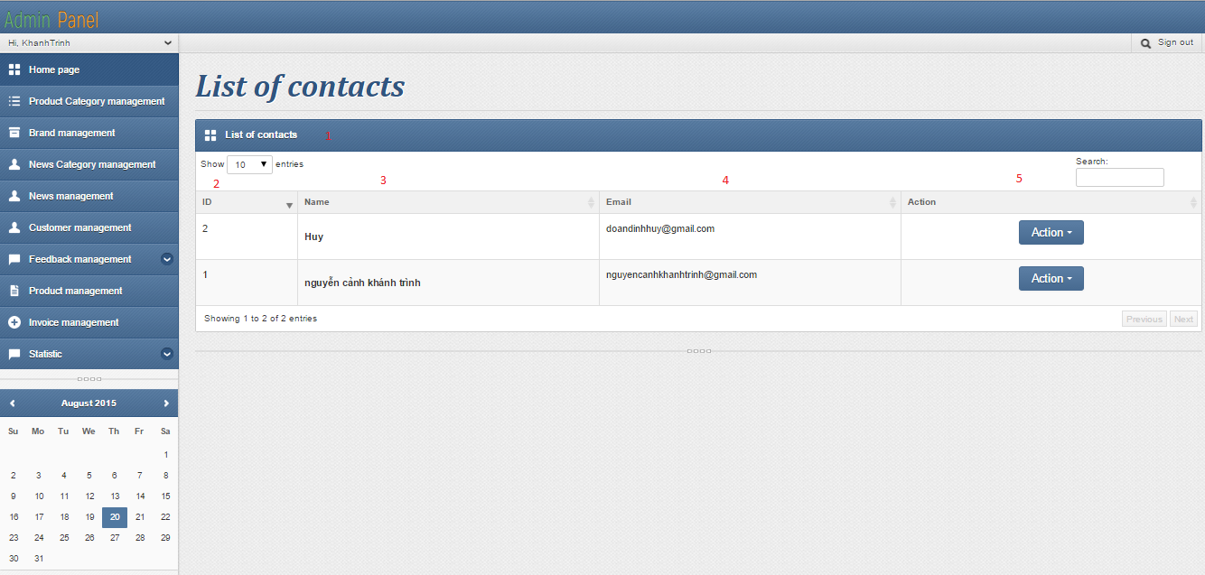

|  |  |  |  |  |  |  |
| --- | --- | --- | --- | --- | --- | --- |
| **No.** | **Name** | **Type** | **Validation** | **Event** | **Description** | **Status** |
| 1 | lvContact | Listview |  |  | Listview contains controls:2,3,4,5 data get from Contact table |  |
| 2 | lblId | label |  |  | User’s Id |  |
| 3 | lblName | label |  |  | User’s name |  |
| 4 | lblEmail | label |  |  | User’s email |  |
| 5 | btnAction | button |  | Click | Redirect to ContactDetail Page or Remove this Contact. |  |

### Detail contact

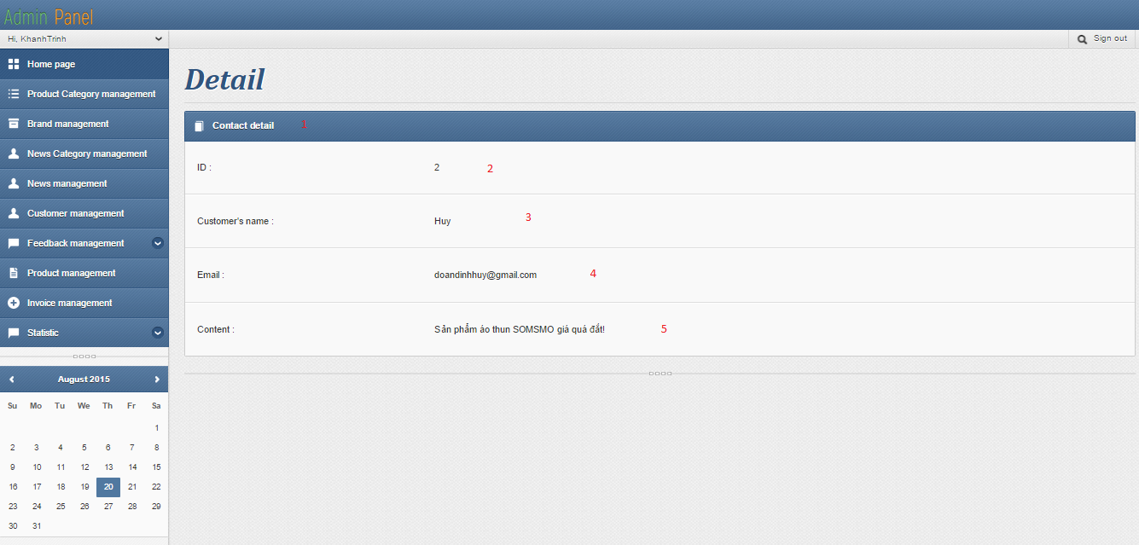

|  |  |  |  |  |  |  |
| --- | --- | --- | --- | --- | --- | --- |
| **No.** | **Name** | **Type** | **Validation** | **Event** | **Description** | **Status** |
| 1 | grdContactDetail | Grid |  |  | Grid contains controls:2,3,4,5 data get from Contact table |  |
| 2 | lblId | label |  |  | User’s Id |  |
| 3 | lblName | label |  |  | User’s name |  |
| 4 | lblEmail | label |  |  | User’s email |  |
| 5 | lblContent | label |  |  | Content of user’s feedback |  |

### Comment manager

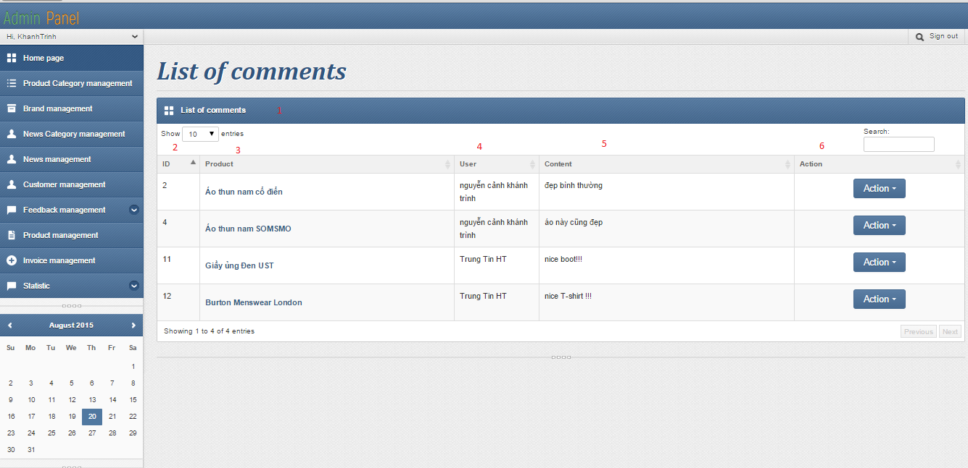

|  |  |  |  |  |  |  |
| --- | --- | --- | --- | --- | --- | --- |
| **No.** | **Name** | **Type** | **Validation** | **Event** | **Description** | **Status** |
| 1 | tbListComment | table |  |  | table contains controls:2,3,4,5,6 data get from Comment table |  |
| 2 | lblId | label |  |  | Comment’s Id |  |
| 3 | lblProduct | label |  |  | Product’s name |  |
| 4 | lblUser | label |  |  | User’s name |  |
| 5 | lblContent | label |  |  | Content of user’s comment |  |
| 6 | btnAction | button |  | Click | Remove comment |  |

### User manager

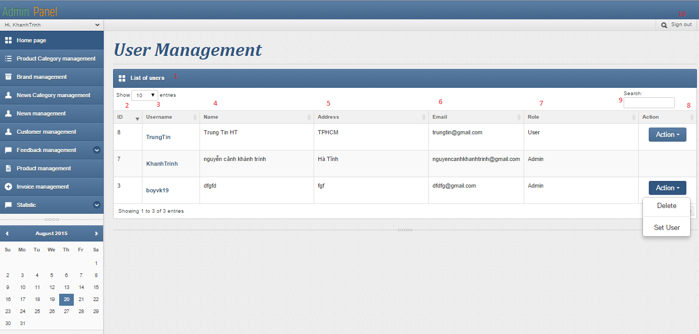

|  |  |  |  |  |  |  |
| --- | --- | --- | --- | --- | --- | --- |
| **No.** | **Name** | **Type** | **Validation** | **Event** | **Description** | **Status** |
| 1 | tbListUser | table |  |  | table contains controls:2,3,4,5,6,7,8,9,10 data get from Customer table |  |
| 2 | lblId | label |  |  | User’s Id |  |
| 3 | lblUsername | label |  |  | Username |  |
| 4 | lblName | label |  |  | User’s full name |  |
| 5 | lblAddress | label |  |  | User’s address |  |
| 6 | lblEmail | label |  |  | User’s email |  |
| 7 | lbRole | label |  |  | User’s role(User or Admin) |  |
| 8 | btnAction | button |  | Click | Set user🡪admin or delete user |  |
| 9 | txtSearch | textbox |  |  | Search user by name |  |
| 10 | btnSignout | hyperlink |  | Click | Log out current user |  |

### List product

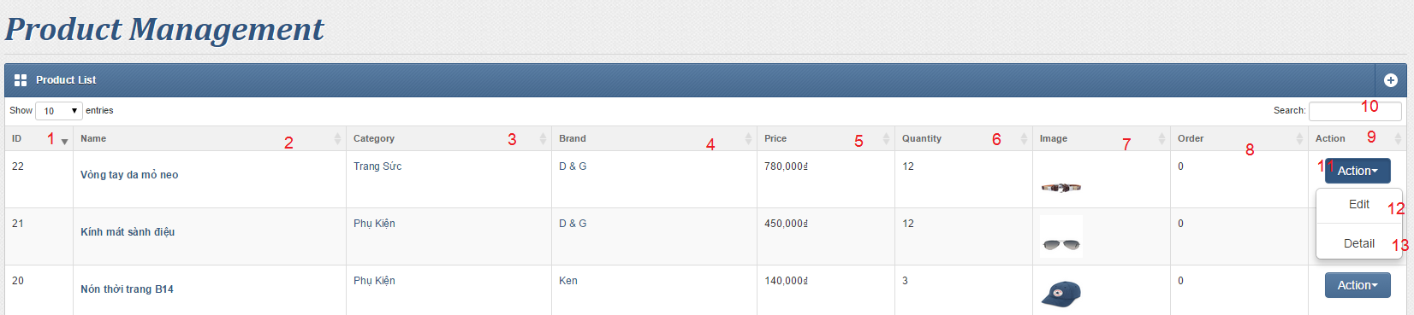

|  |  |  |  |  |  |  |
| --- | --- | --- | --- | --- | --- | --- |
| **No.** | **Name** | **Type** | **Validation** | **Event** | **Description** | **Status** |
| 1 | ID | Label |  |  | Product ID |  |
| 2 | lblName | Hyperlink |  | Click | Name of Product  Redirect to Product Detail |  |
| 3 | lblCategory | Label |  |  | Product Category |  |
| 4 | lblBrand | Label |  |  | Product Brands |  |
| 5 | lblPrice | Label |  |  | Price of Product |  |
| 6 | lblAmount | Label |  |  | Quantity of Product |  |
| 7 | lblImage | Image |  |  | Image Of Product |  |
| 8 | lblPayAmount | Label |  |  | Number or Orders |  |
| 9&11 | lblAction | Dropdownlist |  | Click | Dropdown list to choose Edit/Delete Action |  |
| 10 | txtSearch | Textbox |  | Type | Instance query the product list with key word |  |
| 12 | btnEdit | Hyperlink |  | Click | Redirect to Edit Product Page |  |
| 13 | btnDelete | Hyperlink |  | Click | Remove Product |  |
| 14 | btnAdd | Hyperlink |  | Click | Redirect to Add new Product Page |  |

### Modify product

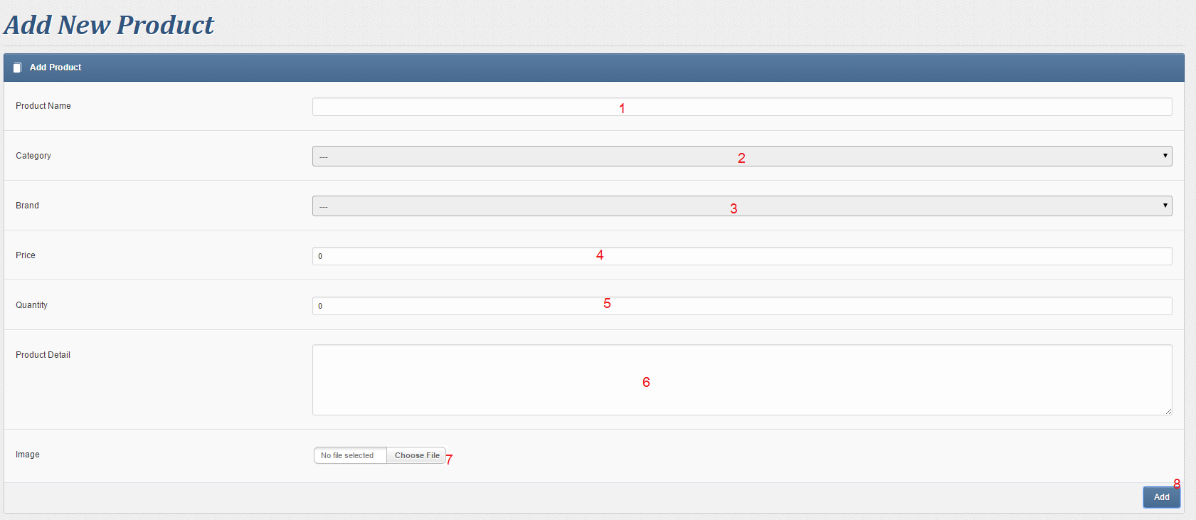

|  |  |  |  |  |  |  |
| --- | --- | --- | --- | --- | --- | --- |
| **No.** | **Name** | **Type** | **Validation** | **Event** | **Description** | **Status** |
| 1 | txtProductName | Text Field | Not Null, Min 3 character, Max 200 Character |  | Product Name |  |
| 2 | drlCategory | Dropdown List | Must Choose Value different than “---“ |  | Product’s Category |  |
| 3 | drlBrand | Dropdown List | Must Choose Value different than “---“ |  | Product’s Brands |  |
| 4 | txtPrice | Text Field | Not Null, Must be a number between 10,000 to 10,000,000 |  | Product Price in Vietnam Dong |  |
| 5 | txtAmount | Text Field | Not Null, Must be a number between 1 to 1,000 |  | Quantity Of product |  |
| 6 | txtDetail | Text Area | Not Null, Must at less 10 characters |  | Details of Product |  |
| 7&8 | imgPicture | Input | Must is image File |  | Image Of Product |  |
| 8 | bntAdd / Edit | Button |  |  | Add/Edit New Product |  |

### Product detail

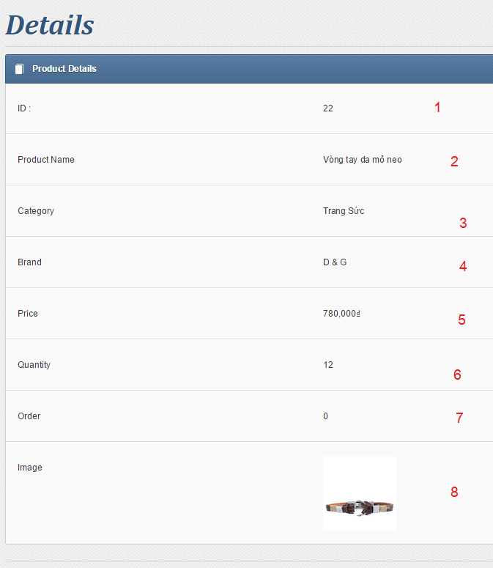

|  |  |  |  |  |  |  |
| --- | --- | --- | --- | --- | --- | --- |
| **No.** | **Name** | **Type** | **Validation** | **Event** | **Description** | **Status** |
| 1 | Id | Label |  |  | ProductID |  |
| 2 | lbProductName | Label |  |  | Product name |  |
| 3 | lbCategory | label |  |  | Product Category |  |
| 4 | lbBrand | label |  |  | Product brands |  |
| 5 | lbPrice | label |  |  | Product Price |  |
| 6 | lbQuantity | label |  |  | Product quantity |  |
| 7 | lbOrder | label |  |  | Orders count of Product |  |
| 8 | lbImage | Image |  |  | Image Of product |  |

### Category manager

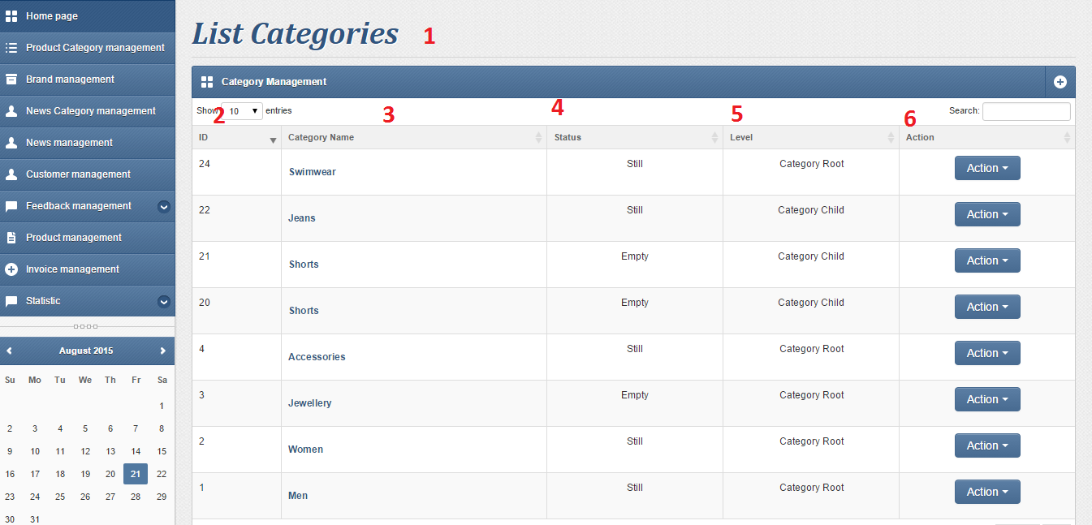

|  |  |  |  |  |  |  |
| --- | --- | --- | --- | --- | --- | --- |
| **No.** | **Name** | **Type** | **Validation** | **Event** | **Description** | **Status** |
| 1 | lvCategory | Listview |  |  | Listview contains controls:2,3,5,6 data get from Category table , 4 get from Product Table |  |
| 2 | lbId | label |  |  | Category’s Id |  |
| 3 | cmdLink | Link |  | Click | Category’s name and Click go to Detail Page |  |
| 4 | LbStatus | label |  |  | Category’s Status |  |
| 5 | LbLevel | label |  |  | Category’s Level |  |
| 6 | btnAction | button |  | Click | Edit / Delete Category |  |

### Category detail

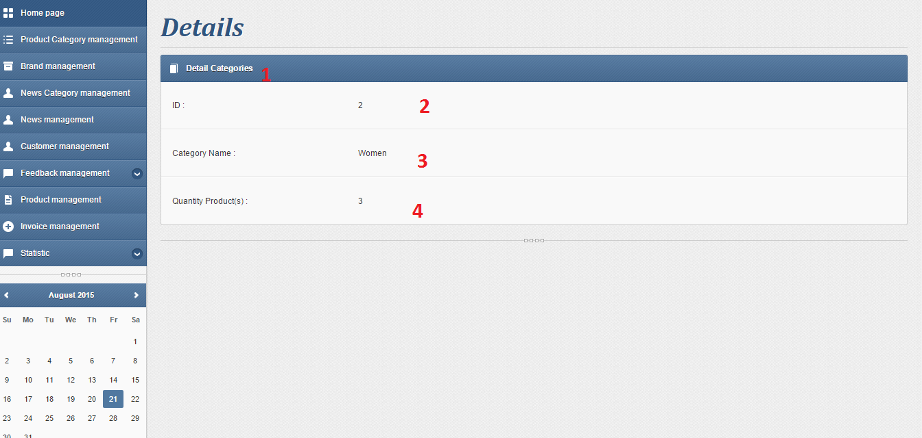

|  |  |  |  |  |  |  |
| --- | --- | --- | --- | --- | --- | --- |
| **No.** | **Name** | **Type** | **Validation** | **Event** | **Description** | **Status** |
| 1 | grdCategoryDetail | Grid |  |  | Grid contains controls:2,3 data get from Category table , 4 get from Product table |  |
| 2 | lblId | label |  |  | Category’s Id |  |
| 3 | lblName | label |  |  | Category’s name |  |
| 4 | lblQuantity | label |  |  | Quantity product in Category |  |

### Add category

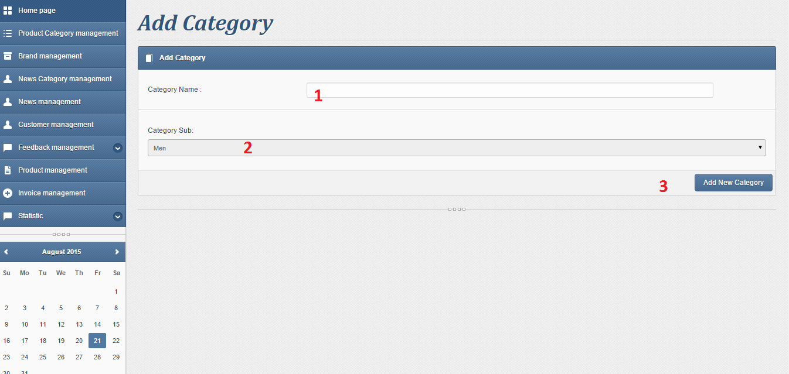

|  |  |  |  |  |  |  |
| --- | --- | --- | --- | --- | --- | --- |
| **No.** | **Name** | **Type** | **Validation** | **Event** | **Description** | **Status** |
| 1 | txtCategoryName | textField | Not null , must be range 3 – 100 characters |  | Category’s Name |  |
| 2 | cbbSub | Combobox |  |  | Category’s Sub |  |
| 3 | btnaddCategory | button |  | Click | Add new Category |  |

### Modify category

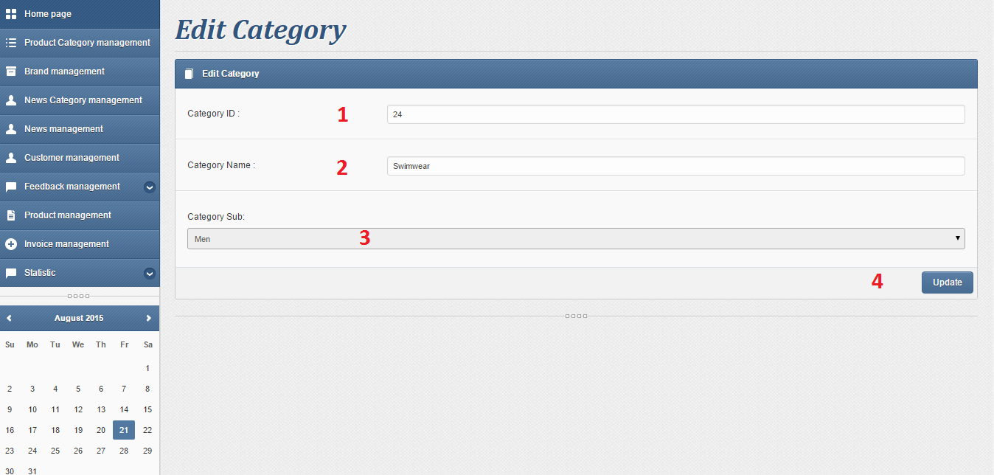

|  |  |  |  |  |  |  |
| --- | --- | --- | --- | --- | --- | --- |
| **No.** | **Name** | **Type** | **Validation** | **Event** | **Description** | **Status** |
| 1 | txtID | textField | Can’t Edit |  | Category’s ID |  |
| 2 | txtName | textField | Not null , must be range 3 – 100 characters |  | Category’s Name |  |
| 3 | cbbSub | Commbobox |  | Select Items | Category’s Sub |  |
| 4 | btnUpdate | Button |  | Click | Edit Category |  |

# Report:

## Customer report:

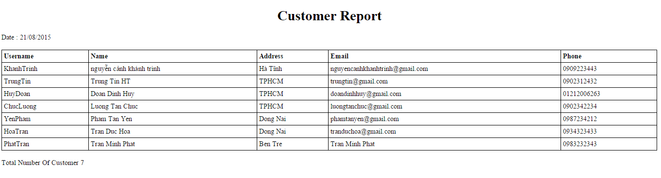

## Brand report:

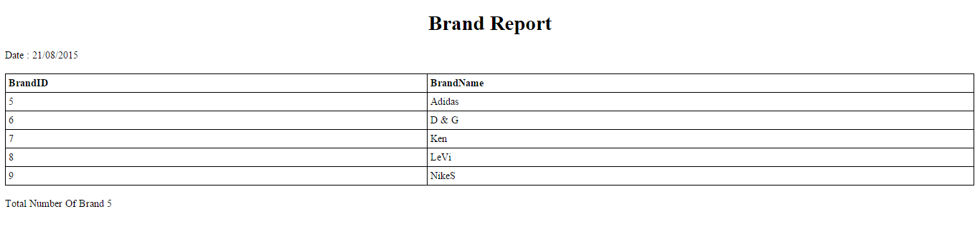

## Order report:

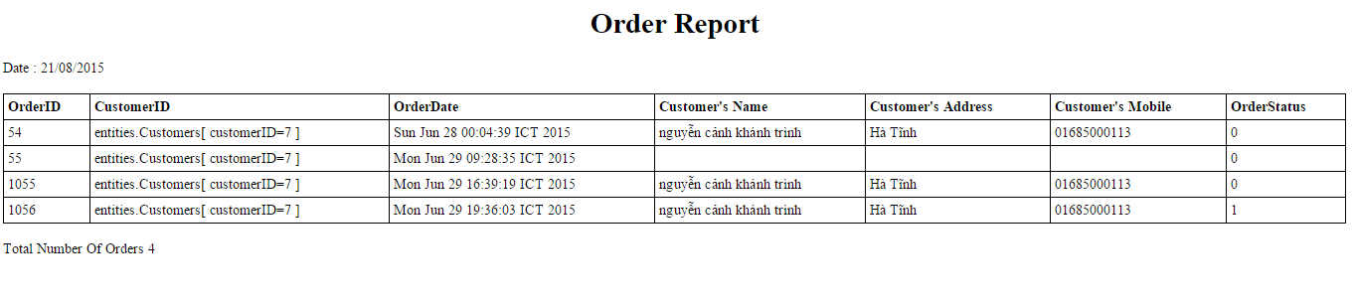

## Product report:

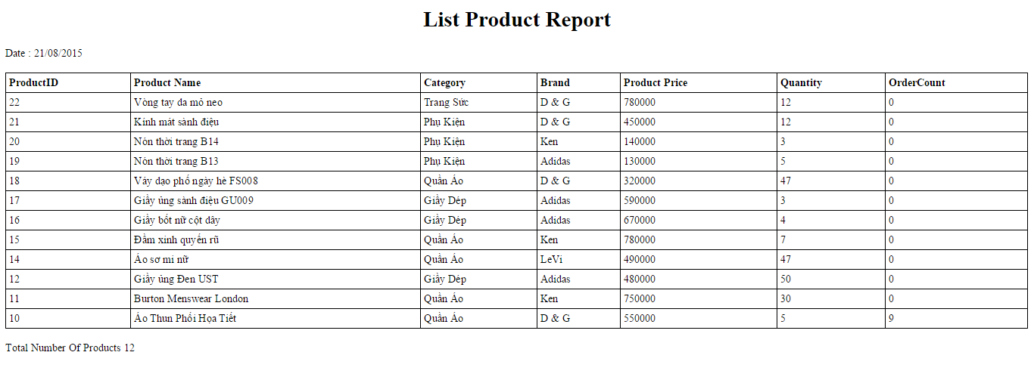

## Feedback report:

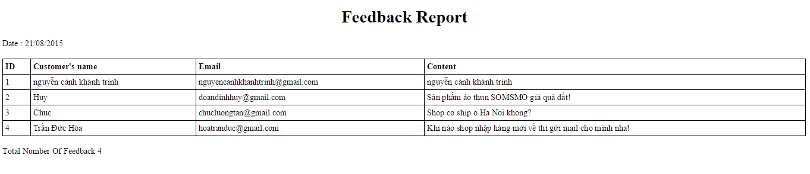

## Product category report:

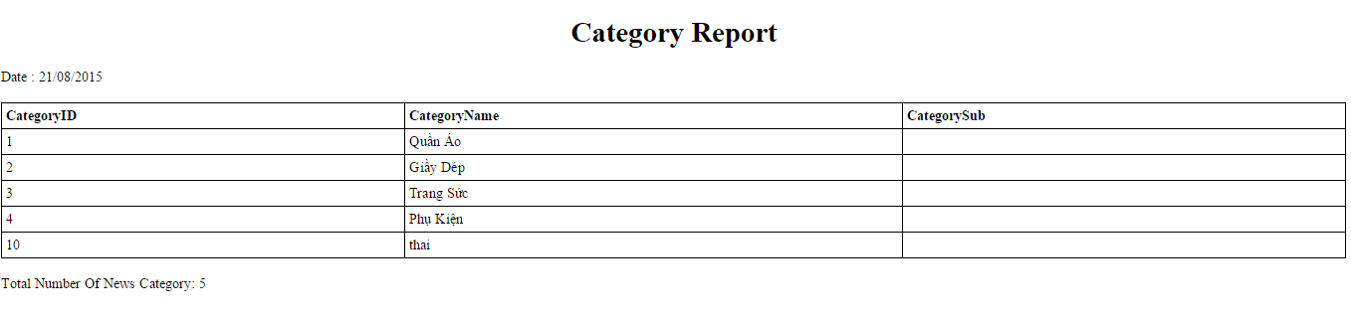

# Task Sheet

|  |  |  |  |  |  |  |  |  |
| --- | --- | --- | --- | --- | --- | --- | --- | --- |
| **Project Ref. No 1** | | **Project Title** | **Activity Plan Prepared By** | **Date of Preparation of Activity Plan** | | | | |
| **Sr. No** | **Task** | **Start Date** | **End Date** | **Actual Days** | **Member’s name** | **Status** |
| **Document** | | | | | | | | |
| 1 | Introduction | FASHION SHOP | Nguyen Canh Khanh Trinh | 03/08/2015 | 06/08/2015 | 03 | All of Team | FINISH |
| 2 | Existing Scenario | FASHION SHOP | Nguyen Canh Khanh Trinh | 03/08/2015 | 06/08/2015 | 03 | All of Team | FINISH |
| 3 | Customer Requirement Specification | FASHION SHOP | Nguyen Canh Khanh Trinh | 03/08/2015 | 06/08/2015 | 03 | All of Team | FINISH |
| 4 | Functional Requirement Specification | FASHION SHOP | Nguyen Canh Khanh Trinh | 03/08/2015 | 06/08/2015 | 03 | All of Team | FINISH |
| 5 | System Requirements | FASHION SHOP | Nguyen Canh Khanh Trinh | 03/08/2015 | 06/08/2015 | 03 | All of Team | FINISH |
| 6 | Development Software | FASHION SHOP | Nguyen Canh Khanh Trinh | 03/08/2015 | 06/08/2015 | 03 | All of Team | FINISH |
| 7 | Technology | FASHION SHOP | Nguyen Canh Khanh Trinh | 03/08/2015 | 06/08/2015 | 03 | All of Team | FINISH |
| 8 | Scope of work | FASHION SHOP | Nguyen Canh Khanh Trinh | 03/08/2015 | 06/08/2015 | 03 | All of Team | FINISH |
| 9 | Use case and sequence diagram | FASHION SHOP | Nguyen Canh Khanh Trinh | 07/08/2015 | 13/08/2015 | 07 | All of Team | FINISH |
| 10 | Entity relationship diagram | FASHION SHOP | Nguyen Canh Khanh Trinh | 07/08/2015 | 13/08/2015 | 07 | All of Team | FINISH |
| 11 | Database relationship | FASHION SHOP | Nguyen Canh Khanh Trinh | 14/08/2015 | 23/08/2015 | 10 | All of Team | FINISH |
| 12 | Table definition | FASHION SHOP | Nguyen Canh Khanh Trinh | 14/08/2015 | 23/08/2015 | 10 | All of Team | FINISH |
| 13 | Other constrains | FASHION SHOP | Nguyen Canh Khanh Trinh | 14/08/2015 | 23/08/2015 | 10 | All of Team | FINISH |
| 14 | Sitemap | FASHION SHOP | Nguyen Canh Khanh Trinh | 14/08/2015 | 23/08/2015 | 10 | All of Team | FINISH |
| 15 | GUI design | FASHION SHOP | Nguyen Canh Khanh Trinh | 14/08/2015 | 23/08/2015 | 10 | All of Team | FINISH |
| **Functional** | | | | | | | | |
| 16 | UserViewProduct | FASHION SHOP | Nguyen Canh Khanh Trinh | 14/08/2015 | 23/08/2015 | 10 | Tran Minh Phat | FINISH |
| 17 | UserSearchProduct | FASHION SHOP | Nguyen Canh Khanh Trinh | 14/08/2015 | 23/08/2015 | 10 | Tran Minh Phat | FINISH |
| 18 | UserRegister as member | FASHION SHOP | Nguyen Canh Khanh Trinh | 14/08/2015 | 23/08/2015 | 10 | Luong Tan Chuc | FINISH |
| 19 | UserLogin | FASHION SHOP | Nguyen Canh Khanh Trinh | 14/08/2015 | 23/08/2015 | 10 | Luong Tan Chuc | FINISH |
| 20 | UserLogout | FASHION SHOP | Nguyen Canh Khanh Trinh | 14/08/2015 | 23/08/2015 | 10 | Luong Tan Chuc | FINISH |
| 21 | UserChangeProfile | FASHION SHOP | Nguyen Canh Khanh Trinh | 14/08/2015 | 23/08/2015 | 10 | Luong Tan Chuc | FINISH |
| 22 | UserChangePassword | FASHION SHOP | Nguyen Canh Khanh Trinh | 14/08/2015 | 23/08/2015 | 10 | Luong Tan Chuc | FINISH |
| 23 | UserFeedback | FASHION SHOP | Nguyen Canh Khanh Trinh | 14/08/2015 | 23/08/2015 | 10 | Doan Dinh Huy | FINISH |
| 24 | UserAddToCart | FASHION SHOP | Nguyen Canh Khanh Trinh | 14/08/2015 | 23/08/2015 | 10 | Nguyen Canh Khanh Trinh | FINISH |
| 25 | UserSubmitOrder | FASHION SHOP | Nguyen Canh Khanh Trinh | 14/08/2015 | 23/08/2015 | 10 | Nguyen Canh Khanh Trinh | FINISH |
| 26 | SetRoleUser/Admin | FASHION SHOP | Nguyen Canh Khanh Trinh | 14/08/2015 | 23/08/2015 | 10 | Doan Dinh Huy | FINISH |
| 27 | UserViewOrder | FASHION SHOP | Nguyen Canh Khanh Trinh | 14/08/2015 | 23/08/2015 | 10 | Nguyen Canh Khanh Trinh | FINISH |
| 28 | StaffLogin | FASHION SHOP | Nguyen Canh Khanh Trinh | 14/08/2015 | 23/08/2015 | 10 | Doan Dinh Huy | FINISH |
| 29 | StaffLogout | FASHION SHOP | Nguyen Canh Khanh Trinh | 14/08/2015 | 23/08/2015 | 10 | Doan Dinh Huy | FINISH |
| 30 | StaffViewFeedbacks | FASHION SHOP | Nguyen Canh Khanh Trinh | 14/08/2015 | 23/08/2015 | 10 | Doan Dinh Huy | FINISH |
| 31 | StaffSearchFeedback | FASHION SHOP | Nguyen Canh Khanh Trinh | 14/08/2015 | 23/08/2015 | 10 | Doan Dinh Huy | FINISH |
| 32 | StaffViewCustomers | FASHION SHOP | Nguyen Canh Khanh Trinh | 14/08/2015 | 23/08/2015 | 10 | Doan Dinh Huy | FINISH |
| 33 | StaffModifyCustomer | FASHION SHOP | Nguyen Canh Khanh Trinh | 14/08/2015 | 23/08/2015 | 10 | Doan Dinh Huy | FINISH |
| 34 | StaffViewOrders | FASHION SHOP | Nguyen Canh Khanh Trinh | 14/08/2015 | 23/08/2015 | 10 | Nguyen Canh Khanh Trinh | FINISH |
| 35 | StaffProcessOrder | FASHION SHOP | Nguyen Canh Khanh Trinh | 14/08/2015 | 23/08/2015 | 10 | Nguyen Canh Khanh Trinh | FINISH |
| 36 | StaffSearchOrder | FASHION SHOP | Nguyen Canh Khanh Trinh | 14/08/2015 | 23/08/2015 | 10 | Nguyen Canh Khanh Trinh | FINISH |
| 37 | StaffViewProduct | FASHION SHOP | Nguyen Canh Khanh Trinh | 14/08/2015 | 23/08/2015 | 10 | Tran Minh Phat | FINISH |
| 38 | StaffAddNewProduct | FASHION SHOP | Nguyen Canh Khanh Trinh | 14/08/2015 | 23/08/2015 | 10 | Tran Minh Phat | FINISH |
| 39 | StaffModifyProduct | FASHION SHOP | Nguyen Canh Khanh Trinh | 14/08/2015 | 23/08/2015 | 10 | Tran Minh Phat | FINISH |
| 40 | Staff SearchProduct | FASHION SHOP | Nguyen Canh Khanh Trinh | 14/08/2015 | 23/08/2015 | 10 | Tran Minh Phat | FINISH |
| 41 | StaffViewBrand | FASHION SHOP | Nguyen Canh Khanh Trinh | 14/08/2015 | 23/08/2015 | 10 | Luong Tan Chuc | FINISH |
| 42 | StaffAddNewBrand | FASHION SHOP | Nguyen Canh Khanh Trinh | 14/08/2015 | 23/08/2015 | 10 | Luong Tan Chuc | FINISH |
| 43 | StaffModifyBrand | FASHION SHOP | Nguyen Canh Khanh Trinh | 14/08/2015 | 23/08/2015 | 10 | Luong Tan Chuc | FINISH |
| 44 | StaffSearchBrand | FASHION SHOP | Nguyen Canh Khanh Trinh | 14/08/2015 | 23/08/2015 | 10 | Luong Tan Chuc | FINISH |
| 45 | StaffViewCategories | FASHION SHOP | Nguyen Canh Khanh Trinh | 14/08/2015 | 23/08/2015 | 10 | Tran Duc Hoa | FINISH |
| 46 | StaffAddNewCategory | FASHION SHOP | Nguyen Canh Khanh Trinh | 14/08/2015 | 23/08/2015 | 10 | Tran Duc Hoa | FINISH |
| 47 | StaffModifyCategory | FASHION SHOP | Nguyen Canh Khanh Trinh | 14/08/2015 | 23/08/2015 | 10 | Tran Duc Hoa | FINISH |
| 48 | StaffSearchCategory | FASHION SHOP | Nguyen Canh Khanh Trinh | 14/08/2015 | 23/08/2015 | 10 | Tran Duc Hoa | FINISH |
| 49 | StaffViewComments | FASHION SHOP | Nguyen Canh Khanh Trinh | 14/08/2015 | 23/08/2015 | 10 | Doan Dinh Huy | FINISH |
| 50 | StaffDeleteComment | FASHION SHOP | Nguyen Canh Khanh Trinh | 14/08/2015 | 23/08/2015 | 10 | Doan Dinh Huy | FINISH |
| 51 | StaffViewNewsCategory | FASHION SHOP | Nguyen Canh Khanh Trinh | 14/08/2015 | 23/08/2015 | 10 | Pham Tan Yen | FINISH |
| 52 | StaffAddNewsCategory | FASHION SHOP | Nguyen Canh Khanh Trinh | 14/08/2015 | 23/08/2015 | 10 | Pham Tan Yen | FINISH |
| 53 | StaffAddModifyNewsCategory | FASHION SHOP | Nguyen Canh Khanh Trinh | 14/08/2015 | 23/08/2015 | 10 | Pham Tan Yen | FINISH |
| 54 | StaffRemoveNewsCategory | FASHION SHOP | Nguyen Canh Khanh Trinh | 14/08/2015 | 23/08/2015 | 10 | Pham Tan Yen | FINISH |
| 55 | StaffAddNews | FASHION SHOP | Nguyen Canh Khanh Trinh | 14/08/2015 | 23/08/2015 | 10 | Pham Tan Yen | FINISH |
| 56 | StaffViewNews | FASHION SHOP | Nguyen Canh Khanh Trinh | 14/08/2015 | 23/08/2015 | 10 | Pham Tan Yen | FINISH |
| 57 | StaffAddNews | FASHION SHOP | Nguyen Canh Khanh Trinh | 14/08/2015 | 23/08/2015 | 10 | Pham Tan Yen | FINISH |
| **Task sheet** | | | | | | | | |
| 58 | Task sheet | FASHION SHOP | Nguyen Canh Khanh Trinh | 03/08/2015 | 23/08/2015 | 30 | Nguyen Canh Khanh Trinh | FINISH |

|  |  |
| --- | --- |
| Leader | Faculty |
|  |  |
| Nguyễn Cảnh Khánh Trình | Dương Trọng Phú Sơn |